
Education Resources

Hamilton School for the Deaf
Handbook 2023/24



Contents

- Introduction

- About our School

- Parental Involvement

- School Ethos

- The Curriculum

- Assessment

- Reporting

- Transitions

- Support for Pupils (Additional Support Needs)

- School Improvement

- School Policies and Practical Information

If you need this information in another language or format, please contact us to discuss how we can best meet your needs.

Phone: 01698 454545 Email: education@southlanarkshire.gov.uk.
1) | Introduction by the headteacher

Welcome from the Head Teacher

Welcome to Hamilton School for the Deaf.

As Head Teacher, it is a privilege to write this introduction to our School Handbook. This Handbook offers a summary of our school and Outreach Service and a general overview of the bespoke educational experience provided by Hamilton School for the Deaf. It cannot however convey the nurturing, happy, respectful, child and family centred environment that our staff have created in partnership with our school community. I do hope that this is something you can experience and evaluate when you visit us, or when you meet with our Outreach Teachers of Deaf Children and Young People. You can keep up to date with our learning experiences by following us on Twitter and through our school website (under construction) or you may wish to contact the school directly. Appointments can be arranged by telephone or e-mail. BSL or alternative Language interpreters can be arranged on request.

It is my desire that every pupil, staff member, parent and carer linked to Hamilton School for the Deaf has a positive, high-quality experience of our school. We cherish our close relationships with parents and carers and enjoy positive interactions with a wide variety of agencies to best meet the holistic needs of all our learners. We are passionate ‘Champions’ of all aspects of Deaf Education and strong advocates for our children, young people and our families.

If you would like to know more about life here at Hamilton School for the Deaf or if you have any questions regarding your child’s education, please do not hesitate to contact me at school where an appointment will be made.



Miss Lauren Brown
Head Teacher
Hamilton School for the Deaf

Hamilton School for the Deaf is a South Lanarkshire resource for children aged from 3 years to 12 years who are deaf. The school is a non-denominational, co-educational establishment. Provision can be made for children whose parents would like them to receive Catholic religious instruction.

The school moved to a new building in April 2007 on a shared campus with Glenlee Primary School. The nursery class is shared with Glenlee. A clear focus of the shared campus is to develop inclusive ethos and practice across the two schools. Our children are included in Glenlee mainstream classrooms for parts of their curriculum depending on individual need. Equally, Glenlee are included into Hamilton School for the Deaf to promote two-way inclusion, when appropriate. The outreach service, which supports children with a hearing loss who attend mainstream and other ASN schools across South Lanarkshire, is also based in the school.

Our aim is to educate our children in such a manner as to allow them to achieve their maximum potential in all areas of life. We aim for them to become confident individuals, effective contributors, successful learners and responsible citizens. We plan for children to have full access to the curriculum and embrace a Total Communication approach comprising of speech, sign (BSL and Sign Supported English), text, visuals and any augmentative alternative communication modes. The languages used within the school are BSL and English. All staff have signing skills and the school is committed to ensuring that staff continue to improve their skills. We believe that if we communicate with pupils in a language they completely understand then this gives them the best chance of attaining in line with their potential.

The curriculum of the school is Curriculum for Excellence. The school aims to provide our children with a curriculum which is relevant to them as deaf young people and personalised to meet individual needs while providing the challenge to ensure that each child has the opportunity to maximise their attainment. We have a strong focus on attainment and aim that our young people will achieve their full potential, with constant assessment of need and intervention from all those who support them. Children who are deaf may experience language deprivation, this is a delay in language development that occurs when sufficient exposure to language, spoken or signed, is not provided in the first few years of a deaf child's life, often called the critical or sensitive period. At Hamilton School for the Deaf, we understand early intervention, parental involvement, and other resources all work to prevent and repair language deprivation. At Hamilton School for the Deaf, all our staff are all highly skilled and include qualified Teachers of Deaf Children and Young People, Specialist Early Years Practitioners, Specialist Support Staff alongside our British Sign Language Tutor. We have the knowledge and expertise to provide the best education provision for deaf children and young people across South Lanarkshire.

We have deaf members of staff who provide valuable deaf role models for our children. Our Deaf BSL tutor also provides sign language instruction to Hamilton School for the Deaf and Glenlee staff and pupils. Classes are also available to our parents and partnerships of Hamilton School for the Deaf.

Deaf Awareness training is provided by our staff and pupils to promote successful interactions and communications between both the hearing and deaf community.

Extra-Curricular
The shared campus enables greater opportunities for children from both schools to participate in lunchtime and after school activities. Now we are emerging from the impact of the pandemic, we are hoping to re-establish the variety of clubs and activities on offer throughout the session. We feel it is important that our deaf pupils have access to school activities even though they often travel to school by taxi. We work in partnership with our parents and transport companies to accommodate for this. We also promote clubs and taster sessions which take place during the school day to widen experiences for our children.

Partnership
Great emphasis is placed on the school’s involvement with parents, local community and the Deaf community as it is the belief that true partnership is the most important factor contributing to the progress and development of the children and their families. There are strong links with other agencies, namely, Speech and Language Therapy, Educational Psychology and Audiology and voluntary deaf organisations. Teachers encourage parental involvement in classes and in the corporate life of the school.

Hamilton School for the Deaf Vision (Draft) Consultation underway
All deaf children and young people across South Lanarkshire will be confident with their deaf identify, be successful in their determination to reach positive destinations, take responsibilities seriously when taking part in political, economic, social and cultural life and have the skills to enable them to contribute effectively within their communities.

Improve access to spoken language through better audiology provision. | Improve and support health and wellbeing of our deaf learners. | Improve Deaf Awareness across South Lanarkshire educational provisions.
Raise standards in literacy. | Raise standards in language and communication. | Raise standards in numeracy.
Improve BSL skills across the school community. | Raise awareness of the world of work and skills for life through provision of positive deaf role models. | Actively work in partnership to meet deaf learners’ needs and support deaf children/ young people, their families and their educational establishments across South Lanarkshire during times of transition.

2) | About our school

The school is situated in the Burnbank area of Hamilton and shares a campus with a mainstream Primary called Glenlee Primary.

Hamilton School for the Deaf has pupils from both North and South Lanarkshire, who are deaf and would benefit from more specialist intensive support or access to the curriculum in BSL. The school is inter- denominational and caters for children who choose Roman Catholic instruction and education.

Within our school we have a nursery which caters for children from aged 3 to 5 years. This is fully inclusive with the Glenlee Primary Nursery and a Total Communication approach is fostered.

The school also operates an Outreach Service to pupils within mainstream and ASN establishments across South Lanarkshire who have a hearing loss.

Inclusion with Glenlee Primary is enhanced by having a shared gymnasium, a shared dining area and Nurture Hive. Hamilton School for the Deaf also has a sensory room which can also be used by Glenlee pupils. We also have shared play facilities as well as designated play areas, although there is free flow between both playgrounds.

The school is compliant with legislation to accessibility. It has access to a wet room, disabled toilets, a stair lift to allow access to the stage and a lift to allow access to the upper floor. Each classroom also has flashing lights to indicate the bell or fire alarm.

The school building is clean and modern and has up to date facilities both inside and out. These include:

- Bright, modern, carpeted classrooms, with pupils having access to a FM system to maximise hearing, both within and out with the classroom.
- Interactive whiteboards in each class to enhance visual teaching and learning.
- Networked computers in each classroom and a wireless network system to allow the use of iPads and laptops in all areas. These are well resourced to allow individual pupils use, if appropriate.
- Well resourced classrooms, including specific materials to enhance the learning of deaf/ Deaf pupils.
- Lots of visual displays to celebrate achievements and display the children’s work.
- Outdoor areas have been well developed to include a Story Circle, Outdoor Classroom, playhouse and role play equipment, climbing wall and a MUGA (Multi Use Games Area) pitch.

You can find the most up to date photographs of our school and learning experiences by following our Twitter accounts (see below)

School Playground and Outside Environment

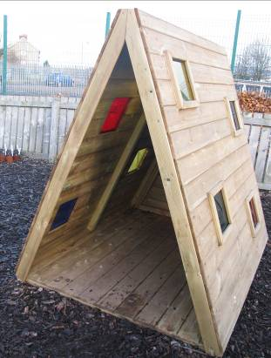
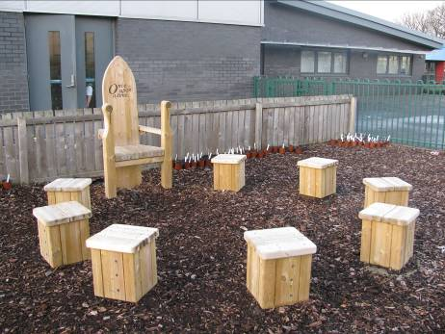
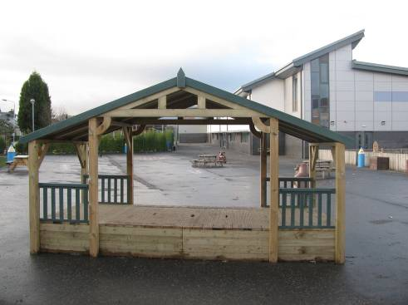

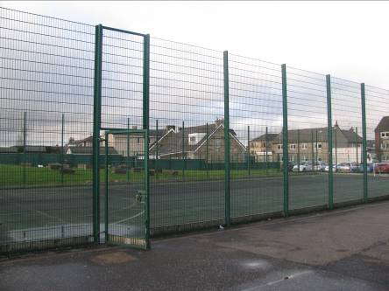
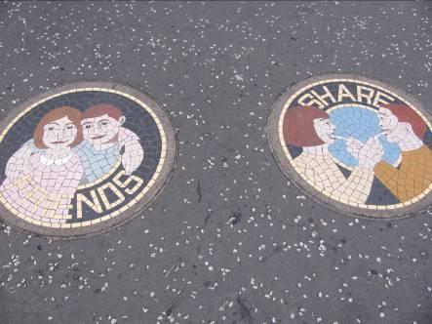
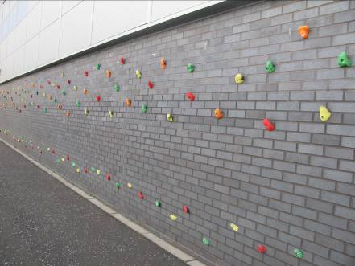

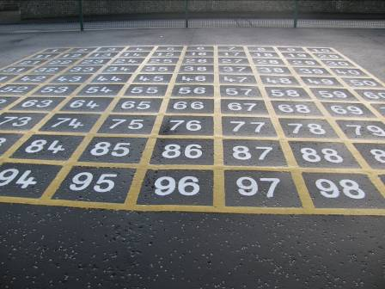
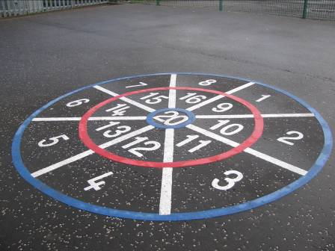
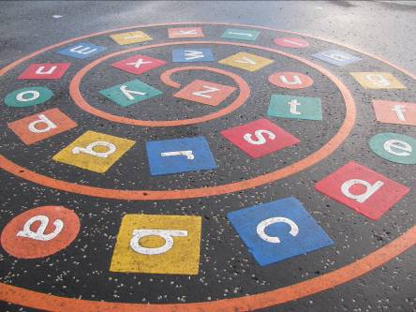

Inside the school

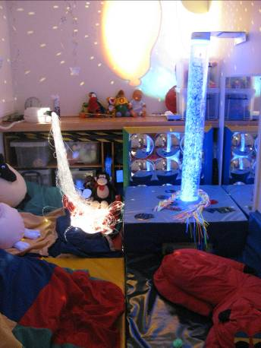
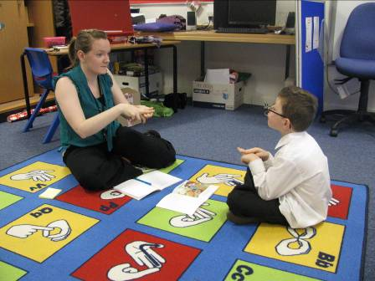
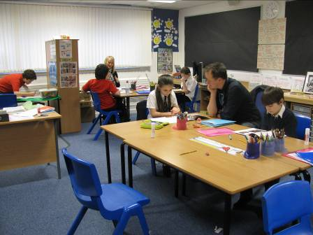

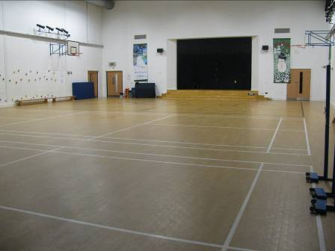

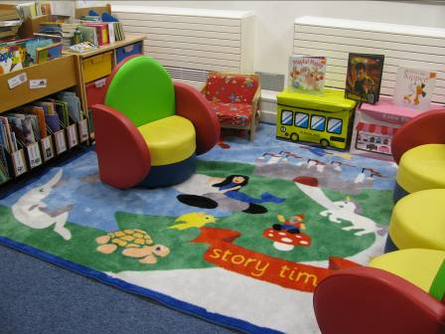
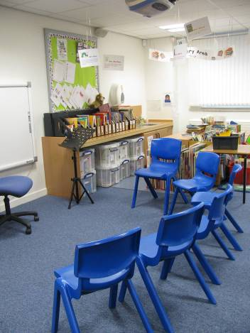

School Address Hamilton School for the Deaf
Anderson Street
Hamilton
ML3 0QL

Telephone Number 01698 823377

Present Roll 13

Maximum Roll 24 – Parents should note that, at present, this allows for 6 pupils in the Nursery and 18 in the Primary.

School/Community We are part of the Calderside Academy Learning Community. We also have strong links with other Agencies such as Audiology, Speech and Language Therapy, Psychological Services for both North and South Lanarkshire, NHS and many others.

School website address: http://www.hamiltonschooldeaf.s-lanark.sch.uk/
School email address: office@hamiltonschooldeaf.s-lanark.sch.uk
Twitter: @HSFDeaf
@HSfDOutreach
@MissBrownHT

Staffing

Senior Leadership Team
Head Teacher | Lauren Brown
Principal Teacher | Vacant
Nursery
Specialist Early Years Practitioner | Debbie MacPhee
Primary
Teachers of Deaf Children and Young People | Jamie Clark, Katie McDougall, Siobhan McGee, Sarah Turnbull, Juli Taylor, Lindsay Campbell, Laura Kane
Support Staff | Anne McCafferty, Jordan Kerr, Meghan Docherty
Outreach
Visiting Teachers of Deaf Children and Young People | Laura Hogg, Joanne Lindsay, Siobhan McGee, Colette Gray, Lisa Shaw

The school is the base for South Lanarkshire’s Primary Outreach Service for children with a hearing loss. The Head Teacher is responsible for the management of this service. Many of our staff work across both sectors of our service.

Janitor Mrs Andrea Kelly + 7 Cleaners (both schools)

Kitchen Staff 1 Cook + 4 Dining Assistants (both schools)

Educational Audiologist Jean McAllister (based at Hamilton School for the Deaf)

Speech and Language Therapy Team Yvonne McKeown and Leanne Thompson (Wednesday)

British Sign Language Tutor Alan Sanders

Attendance at School
We consider that attendance at school and Nursery is important. All absences must be recorded by law. These normally fall into one of two categories – authorised absences or unauthorised. If you fail to inform the school of your child’s absence it will be considered an unauthorised absence.
If your child is unable to attend school, it is important that you notify the school either by telephone or by texting the school’s mobile number. You should state the reason for absence and the possible return date.
It is important to note that NHS advise that in certain illnesses (e.g. sickness and diarrhoea) children should not be sent to school for 48 hours (2 days) after the last symptom of that illness. Should you be unsure on these details, you will be given advice when you notify the school of the absence.
It is also important that the school has up to date contact and emergency details to contact home. Please advise the school of any changes in:
- home telephone number
- mobile number of all contacts (particularly important if they are Deaf)
- emergency contact details.
For absences relating to holidays during term time, please see section 11 of this handbook.

Complaints and Concerns
Our aim is to have a safe and happy environment where all children can thrive and learn to their full potential. It is therefore important to let us know of any concerns in order for us to deal with them. Daily contact is made with the class teacher through the home/ school diary. We will take every concern seriously. This communication also allows us to learn of issues from home which may affect the child’s learning.
Deaf parents can also choose to contact the school via mobile texting or using the Textphone service.
We also have an ‘Open Door’ policy where we welcome parents/ carers to the school and are willing to discuss all concerns. On most occasions it would be advisable to make an appointment in order to check availability and, in some cases, to provide the use of an appropriate Interpreter.
South Lanarkshire Council also provide a policy named “Your Comments, Compliments and Complaints” which is available in the school should it be required.

Transport
As our children come from all over both North and South Lanarkshire, they usually are transported by taxi with an appropriate escort. If your child is absent or at an appointment, we ask for you to contact the taxi directly to cancel. Should you be visiting the school, it is important that cars are only parked in the appropriate places. You should never park in the bus bay as this is a drop off point. If you park in a space designated as disabled, you must always display your blue badge permit.

Placement of Children in the School
Should you wish your child to attend our school, you are welcome to come and visit and discuss the placement. The decision to offer a place does not rest with the Head Teacher of Hamilton School for the Deaf. There is a forum process that must be followed, and the final decision is made by a panel from Inclusive Education. If you wish more details on this process, please feel free to contact us to discuss this further.
3) | Parental Involvement

South Lanarkshire Council recognises the importance of parents as partners in the education of their child and has published a strategy entitled, ‘Making a difference – working together to support children’s learning’. This is available from the Council’s website: www.southlanarkshire.gov.uk

Parents, carers and family members are by far the most important influences on children’s lives. Children between the ages of 5 and 16 children spend only 15% of their time in school! Research shows that when parents are involved in their child’s learning, children do better at school and throughout life. Parental involvement can take different forms, but we hope you share the same aims and agree that by working together we can be partners in supporting children’s learning.

As parents/carers we want you to be:

- Welcomed and given an opportunity to be involved in the life of the school.
- Fully informed about your child’s learning.
- Encouraged to make an active contribution to your child’s learning.
- Able to support learning at home.
- Encouraged to express your views and involved in forums and discussions on education related issues.

To find out more on how to be a parent helper, or a member of the Parent Council and/or the Parent Group please contact the school or visit our website.

Some useful information contacts for parents to find out more on education are as follows: -

- Parentzone – www.parentzonescotland.gov.uk
- Engage Parent Forum – www.engageforeducation.org
- National Parent Forum for Scotland – www.educationscotland.gov.uk/parentzone
- South Lanarkshire Council – www.southlanarkshire.gov.uk

Parent Group
We do not currently have a Parent Council. We have recently established a Parent Group. This is run by one of our primary parents, in partnership with the Head Teacher. We welcome any parents/carers from those receiving support from Hamilton School for the Deaf, including our Outreach team. If this is something you would like to be involved in, please get in touch. Our Parent Group Representative is Mrs Gemma McDonald who would be happy to give you more information on life at Hamilton School for the Deaf from a parental point of view and share the vision of the Parent Group. If you wish to contact her you can do so via WhatsApp 07305042349 and be added to the Parent Group chat.

4) | School Ethos

Hamilton School for the Deaf (HSD) aims to be a welcoming, friendly place where all stakeholders – pupils, parents and staff – feel valued and respected as individuals.
We regularly celebrate achievements at our weekly whole school/nursery campus assembly. The assembly is fully inclusive, deaf awareness strategies are employed, all video and songs are subtitled, all audio is amplified and synchronised to any Assisted Listening Devices. All assemblies are signed. Our pupils lead on sharing signs of the week at each assembly. This also helps to promote a positive Deaf identity and mutual respect of both spoken and sign language.

At Parent’s night one parent commented that she liked that the school celebrated all aspects of what the pupils do. She commented:

“We feel that our son has made tremendous progress. He is enthusiastic. He is eager to learn. He absolutely loves school. He has made a huge improvement.”

One of our Nursery parents commented when speaking of her daughter:

“My child is happy and likes learning new things. The activities are fun”

Spiritual, social, moral and cultural values (religious observance)

HSD is inter-denominational, and all faiths are welcome. All pupils have the opportunity to take part in appropriate religious education following the Curriculum of Excellence guidelines. In addition, there are basic moral discussions throughout the school curriculum and regular school assemblies. We have contacts and support from various school chaplains:

Anne Paul from Gilmore and Whitehill Parish Church is our chaplain representative for our campus. Pupils have the opportunity to be involved in special projects and attend celebratory events at the church. We respect all faiths and build this into our curriculum. We visit many places of worship and welcome Scottish Ethnic Minority Deaf Charity into school to learn more about the faith of Islamic pupils.

Father Jim Morris is a regular visitor to HSD, leading Mass for RC children on Holy Days. Glenlee staff also join with us. He provides excellent support to the teacher who prepares RC pupils for the Sacraments but is respected and admired by all pupils in the school.

Invites will be given to parents to attend these services where appropriate and BSL interpreters will be provided when available/appropriate.

Rights of Parents/Carers
Scottish Government Ministers consider that religious observance complements religious education and is an important contribution to pupils’ development. It should also have a role in promoting the ethos of a school by bringing pupils together and creating a sense of community.
There is a statutory provision for parents to withdraw children from participation in religious observance. This right of parents’ wishes will be respected. When a child is withdrawn from religious observance, schools will make suitable arrangements for the child to participate in a worthwhile alternative activity.

Equalities
Integral to this guidance is the principle of mutual respect. The diversity of belief and tradition provides an ideal context in which pupils can learn about, and so learn from, what is important in the lives of themselves and others. South Lanarkshire’s guidance recognises and welcomes diversity and promotes respectful understanding.

Parents may request that their children be permitted to be absent in order to celebrate recognised religious events. Advance notice should be provided to the school when children will be absent. Appropriate requests will be granted, and the pupil noted as an authorised absentee in the register.

5) | The Curriculum

Curriculum for Excellence is the name given to the curriculum in Scotland for all children and young people aged 3-18. It is a forward looking, coherent, more flexible and enriched curriculum that provides young people with the knowledge, skills and attributes they will need to flourish in life, learning and work, now and in the future.

The curriculum includes all the experiences that are planned for children and young people to support the development of their skills, wherever they are being educated, for example in the family and community, pre-school centre, nursery and school. This broad, general education will allow them to become Successful Learners, Confident Individuals, Responsible Citizens and Effective Contributors to life in the 21st century.

In taking this forward our school will work closely with South Lanarkshire Education Resources and other services to enable Curriculum for Excellence to be fully embedded, ensuring the best possible education for all children and young people. We wish you to feel confident that your child is encouraged and supported to develop their literacy, numeracy and other skills whilst they attend our school. As a School for the Deaf, we also include Deaf Studies as part of our curriculum. The curriculum areas are as follows:

- Expressive arts
- Languages and literacy, including BSL
- Health and wellbeing
- Mathematics and numeracy
- Religious and moral education
- Science
- Social studies
- Technologies
- Deaf Studies

If you want to know more about Curriculum for Excellence, please visit website www.curriculumforexcellence.gov.uk or www.parentzonescotland.gsi.gov.uk

Our learning and teaching activities are based on the outcomes and experiences in the guidelines that all schools have for Curriculum for Excellence.

Level | Stage
Early | The pre-school years and Primary 1 or later for some.
First | To the end of Primary 4, but earlier or later for some.
Second | To the end of Primary 7, but earlier or later for some.

The flexibility of Curriculum for Excellence allows us to build a curriculum which is relevant to our pupils as deaf learners and individuals. Our aim is to provide full access to the curriculum for our pupils.

One parent wrote the comment at a recent parents’ night,

“The school is helping my son by allowing him to learn in different ways and he is starting to do well.”

Another parent commented,

“We are both delighted with our son’s progress; he is excelling himself!”

The Nursery and Primary children are taught within the school but have inclusion links with Glenlee Primary, our shared campus mainstream primary. This dual-campus model allows for an immersion approach (deaf working with deaf) and inclusion (deaf and hearing working together). This allows intensive teaching in a small group situation particularly focussing on language acquisition while allowing opportunities to mix and work in a larger group situation together with hearing peers.
Our children join their stage mainstream class for parts of the curriculum. Whether they learn in Hamilton school for the Deaf or a mainstream class is decided on individual need and where children will learn best. Access to signing is provided on each occasion, usually by a Teacher of Deaf Children and Young People. Staff work jointly across campus to plan and deliver the curriculum and wider learning experiences, when appropriate.

Active learning is used throughout the school with many opportunities for repetition, review and revisiting, particularly in literacy. Each pupil has an individual Additional Support Plan where school and home targets are agreed in consultation with both the parents and the child. These are reviewed at annual Review Meetings.

Digital technology is embedded throughout the curriculum and the school is well sourced with interactive whiteboards in each class, networked computers and iPads to give IT access to every child on a regular basis. Pupils are encouraged to make their own PowerPoint presentation which they show to others at our assemblies. The four capacities for CfE are regularly celebrated at these assemblies. One parent commented not only on her son’s work but also that we recognise the importance of wellbeing.

“Good to hear you are looking after the little ones. Keep up the hard work and good behaviour.”

Outdoor learning is being further developed and pupils have opportunities to take part in projects such as Bikeability, Outdoor Education sessions and swimming.
There are opportunities to present signed singing at joint assemblies, parents’ coffee mornings and in our local community.
We participate in Eco Schools and currently have a Silver Award. The Pupil Council operates across the campus and we have a Pupil Council Representative from Hamilton School for the Deaf who attends these meetings. Pupils are supported by a member of staff from the school to support communication and understanding.

Here is just a snapshot of some of the activities done throughout the years.

Flexible learning approaches

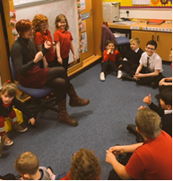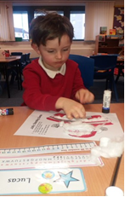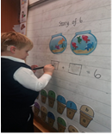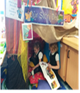

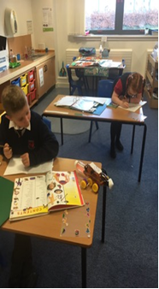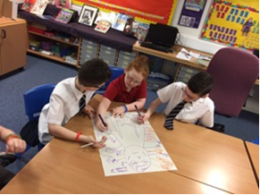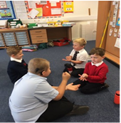

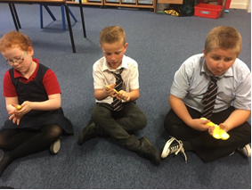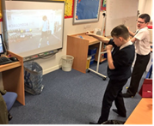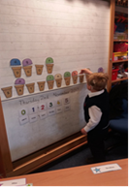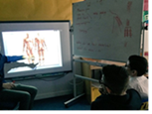

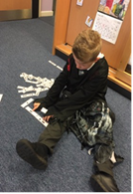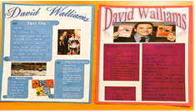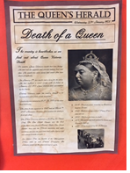

Creative Activities

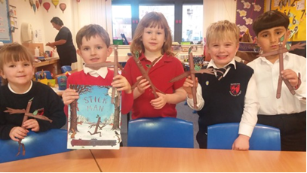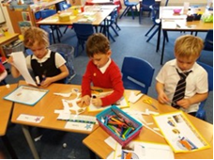

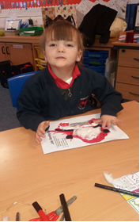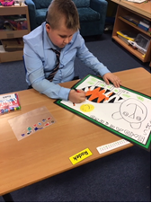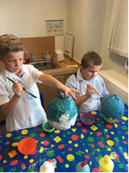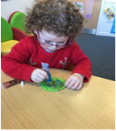

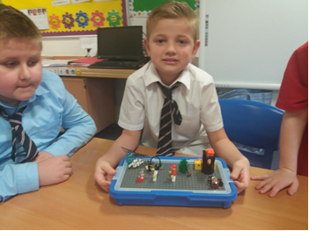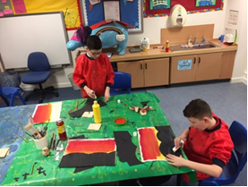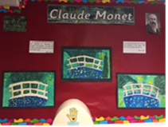

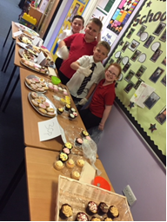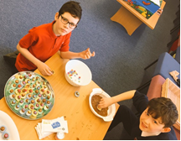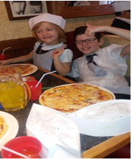

Deaf Role Models

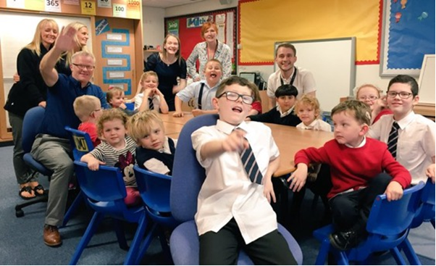

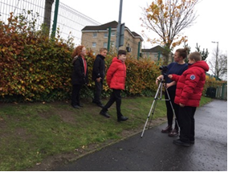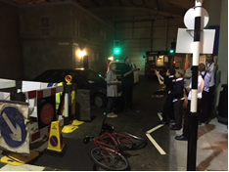

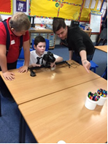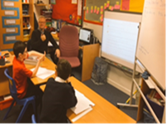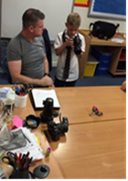

Outdoor Learning

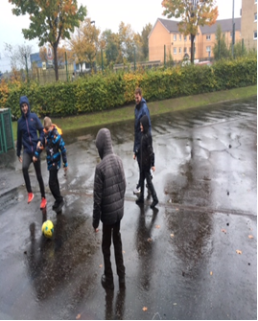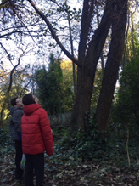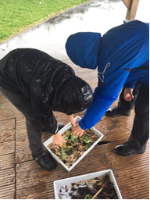

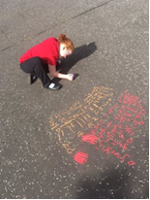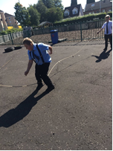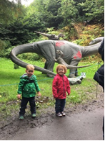

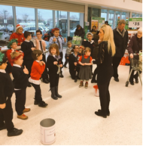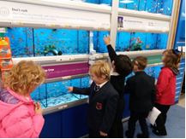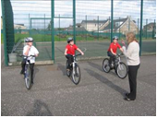

And many more other experiences

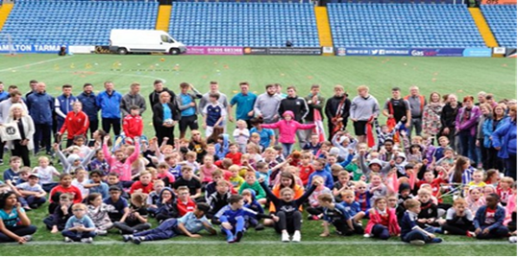
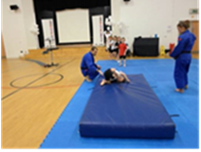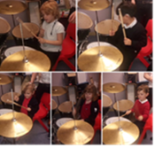

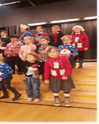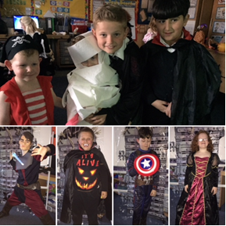

6 | Planning and Assessment

“Assessment involves gathering, reflecting on and evaluating evidence of learning to enable staff to check on learners’ progress and support further learning.”
www.educationscotland.gov.uk

Planning
Teachers work collegiately across the school to share expertise and to provide the best learning experiences for our learners. When appropriate, teachers jointly plan with their Inclusion partners from Glenlee Primary. Skills for Learning, Skills for Life and Skills for Work are a focus for us at Hamilton School for the Deaf. This includes:

- literacy
- numeracy
- health and wellbeing
- employability, enterprise and citizenship
- thinking skills

We have maintained excellent relationships with our supportive partnerships to enhance the learning experiences for our learners and promote these skills through joint projects e.g., Deaf Action – delivering workshops on independent travel for deaf people, professional deaf role models. Parents are a crucial partnership in our planning. We use e-mail and promote two-way communication between home and school. We encourage our parents and carers to share news from home to allow us to teach the language and concepts of experiences from home and to bring children’s own interests into planning.

Assessment
At Hamilton School for the Deaf progress is monitored on a daily basis and planning for next steps in learning is responsive to this progress for each child. Each lesson has clear Learning Intentions and Success Criteria which identifies the purpose of the learning and steps to success. These are bespoke to each child. This is possible due to the small class sizes and the fact that every teacher knows their children very well.

We have a holistic approach to assessment. Each teacher tracks their individual pupils’ progress using targets from ASPs, CfE benchmarks, formal assessment tools and GIRFEC indicators. Teachers are continuously assessing learning on a daily basis and share learner progress regularly with learners, parents, other relevant professionals (Speech and Language Therapists) and the Head Teacher. This process allows us to monitor and track progress and deliver planned interventions to ensure our learners are on a continuous journey of progress and achievement.

The evidence for progress is collated not only on paper but also by videos on iPads. This allows our learners to be more engaged with the assessments and be able to express themselves fully. Feedback from staff is videoed and available to children via a QR Code. This makes feedback accessible.

7) | Reporting

Reporting to parents and carers is ongoing and comprises of a range of activities which can include children presenting their learning through photographs via Twitter or Snapshot jotters, e-mail updates, discussions, annual review meetings and parent meetings.

We provide parents with detailed annual reports, for our parents who have a first language in BSL, these reports are translated into BSL by an interpreter. In addition, parent meetings are offered to all parents and carers which offer you the opportunity to discuss your child’s progress and for parental feedback to be shared. The school will offer you an appointment time so that you can visit in person to discuss your child’s education and a BSL or language interpreter can be arranged at your request.

Our ‘pupil reports’ will help you to get to know more about the curriculum which each child follows and will describe their strengths, achievements and areas for development so you know what encouragement and support you can give.

We welcome any comments or additional information from parents to help us provide the best possible education for your child.

8) | Transitions

As outlined on page 7 of this handbook, placement in a specialist provision is decided by a forum from Inclusive Education however most of our Nursery children then enter Hamilton School for the Deaf Primary and our Primary 7 children transfer to Calderside Academy which has a Deaf Education Department.

Transitions are well supported by review meetings prior to the decision on placement. Parents contribute to this as well as associated health professionals, educational psychologists and staff from each provision.

Babies – 3 Years

Once a baby or child up to aged 3 has been diagnosed with a hearing loss our Educational Audiologist, who liaises with audiology, will contact the family very soon afterwards to share with you the services of Hamilton School for the Deaf. Our Educational Audiologist shares impartial information on communication modes and educational placements. They support families in arranging visits to identified educational settings and provide Deaf Awareness training to staff before the child enters the provision. The Educational Audiologist will create bespoke transition plans depending on the need of the child and their family.

3 Years - Nursery

Once a child is 3 years old, they are supported by our Teachers of Deaf Children and Young People, whether that be in Hamilton School for the Deaf or in mainstream or ASN settings. Joint planning and visits between our Educational Audiologist and our Outreach Teachers of Deaf Children and Young People or Specialist Early Years Practitioner assist in ensuing transitions are positive and well supported, wherever the placement. Deaf Awareness training is provided to all establishments alongside training on any audiological equipment provided.

Nursery – P1

If a child enters into Hamilton School for the Deaf Nursery and then onto our Primary 1 class, there are many opportunities to aid transition. This happens as soon as they are settled into their nursery routine. Our nursery children have regular opportunities to learn and socialise alongside their deaf peers in the primary department throughout their time in nursery. By the time the children are transitioning into P1 in April, we focus on the transition into their P1 Glenlee class. We work closely with our primary colleagues in Glenlee to support transitions, when appropriate. The class teacher will make visits to the children in the nursery setting. Children will follow the same transition process as that of their hearing peers from Glenlee Nursery but will be fully supported by staff from Hamilton School for the Deaf. If enhanced transitions are required, we will work alongside parents and our colleagues in Glenlee to plan and implement this. Deaf Awareness training is delivered to Glenlee staff annually to promote effective communication.

The same process applies to deaf nursery children in our Outreach service. Teachers of the Deaf work in partnership with parents, nursery and school staff to support transitions into P1. Staff attend Transition Meetings to share information and to plan for an effective transition. Deaf Awareness and audiological training is delivered prior to the child arriving and schools are given up to date information on the level of support provided by the Outreach team.

Secondary

The decision for Secondary placement begins early in Primary 6. This includes review meetings to allow parental and pupils views to be considered prior to the considerations of the Secondary forum.

From Primary 7 to S1 there is an extensive transition process. Staff from Calderside Academy Deaf Education Department come to Hamilton School for the Deaf once a week to introduce aspects of Secondary life. There then follows a period of extended visits to the Academy by P7 pupils. This allows them to meet the key staff from Deaf Education and other Deaf pupils, learn the school’s layout and varied subjects and familiarise themselves with the much more extensive environment. They also participate in the usual P7 transition process, meeting up with other P7 children from other schools. This allows the transition period to be as smooth as possible. Some children choose to transfer to other provisions. A similar transition programme is planned for at those times.

For P7 children supported by Outreach, the same process applies. Our staff attend Transition Meetings and are involved in supporting the transition process to secondary school. Teachers of Deaf Children and Young People will plan transition targets for each pupil and focus on building confidence around language of secondary school, how equipment will be managed discretely, ensuring all staff are deaf aware, navigating the school timetable, building in time to collect and drop off audiological equipment and any other concerns the young person has. Their Teacher of Deaf Children and Young People will see them through their S1 transition and support them through their secondary education. This provides a constant for the pupil during times of transition and a support to the new school as the Outreach team knows the pupil well and can share information to ensure needs are met. A Personal Passport is completed. This is a document that brings together all the most important information about the young person so any adult caring for them or working with them can support them in the best way possible.

If you require further information, please contact Education Support Services on 01698 454102.

Post-Secondary Transitions - Outreach only

When a young person reaches 6th year, we support the school, pupil and their families in transitioning from Paediatric Audiology service to Audiology services. From 4th year on, we attend meetings and hold conversations with the young person, their parents/carers and the school identify the post-secondary school destination. We contact the destination, whether it be further education or a workplace and offer Deaf Awareness. A Personal Passport is completed. A personal passport is a document that brings together all the most important information about your son or daughter so that any adult caring for them or working with them can support your child in the best way possible. Teachers of Deaf Children and Young People liaise with Disability Officers to support and create a bespoke transition programme suiting the needs of each young person.

9) | Support for Pupils

Getting it right for every child, (GIRFEC)
Getting it Right for Every Child (GIRFEC) was promoted and endorsed by the Scottish Government at the Children’s Summit in 2010. There is a commitment to ensure that your child has the best possible start in life and to improve outcomes for children and families based on a shared understanding of their wellbeing. Most children make their journey from birth to the world of work supported by family and the universal services of Health and Education. The Named Person in education helps to make sure that the child’s wellbeing is developing. The school will let you know the named person for your child. This is likely to be the headteacher in a primary school and the pupil support teacher in a secondary. For any child attending Hamilton School for the Deaf, the Head Teacher (Lauren Brown) is the Named Person. For children who are under 3 years and not in nursery provision, the Named Person is your Health Visitor. For any child above 3 and in education, it is the Head Teacher or Manager of the nursery or school.

If you have any concerns, you should speak to the Named Person who will work with you to address any issues and to ensure that your child gets any help needed at the right time.

More information can be found on: www.girfecinlanarkshire.co.uk and www.scotland.gov.uk/gettingitright
When completing her ‘What I think tool’ to get her views, one Nursery child signed
“All here are my friends. Deaf. Hearing. Doesn’t matter. All are my friends.”

Support for All (Additional Support Needs)
All children at Hamilton School for the Deaf, Primary and Nursery, have Additional Support Plans in place to support individual needs. Parents and carers work in collaboration with Teachers of Deaf Children and Young People to contribute to these and set targets and a review meeting is organised annually to discuss each child’s progress and next steps. Parents are encouraged to contact the school at any time to discuss the needs of their child.

The services of associated Health Professionals e.g., audiology/ speech and language therapy can also contribute to the plan where appropriate once the Sharing your Information document has been signed.

South Lanarkshire Education Resources have published a series of leaflets which cover information for parents and carers about the Additional Support for Learning Acts.

In keeping with duties set out in the Education (Additional Support for Learning) (Scotland) Act 2004 (as amended) the guidance states that handbooks should specifically mention Enquire, the Scottish advice service for additional support for learning.

Enquire is funded by the Scottish Government to provide information on the framework for supporting children who require additional support for learning and to encourage positive partnerships between families, schools and local authorities to ensure children get the right support.

Enquire – the Scottish advice service for additional support for learning

Enquire offers independent, confidential advice and information on additional support for learning through:

Phone Helpline: 0345 123 2303

Email Enquiry service: info@enquire.org.uk

Advice and information is also available at www.enquire.org.uk

Enquire provides a range of clear and easy-to-read guides and fact sheets including The parents’ guide to additional support for learning.

If you would like to order our leaflets, postcards or guides to share with parents and carers of pupils in your school, please contact us on info@enquire.org.uk

10) | School Improvement

Our Priorities for 2023/24 | Priority 1  Primary | Priority 2  Outreach/Nursery | Priority 3  Campus
Our Priorities for 2023/24 | Developing planning, evaluation, tracking and monitoring in Literacy to raise attainment and inform planning. | 0-3 Deaf Education review and restructure. | Developing ‘Leadership of Learning’ to support children taking responsibility for their own learning, successes and achievements and understand their rights.
What do we want to achieve? | Transition on to our new tracking and monitoring systems to develop SMART targets for incremental steps in literacy to inform planning and ASPs. | Develop a good practice protocol and parental information following national guidance, to ensure consistency and set high expectations for supporting deaf 0-3s across SLC.  - All deaf 0-3 year olds will be effectively supported by our Outreach Department and Specialist Early Years Practitioner. | Establish a cross/campus working party to develop ‘skills for learning’ progression framework from Nursery to P7.  Begin our journey as a Rights Respecting campus to develop awareness of children’s rights within our school community.
How will we know? | All learners tracked and monitored on Bsquared to inform bespoke targets in our planning for our learners.  ASP targets are achieved by learners. | Completed ‘Good Practice’ guide created and followed by staff.  Parental support materials created and distributed. | Cross Campus working group established and ‘Skills for Learning’ progression pathway created for session 24/25.  Achieve Bronze Award (UNCRC).

Successes from Session 22/23
SLT
Theme: Leadership
HGIOS4 QIs: 1.3 Leadership of Change
Assertion | Increased leadership at all levels across the school community.
Action | Sharing research on the impact of leadership at all levels. Recognising staff were looking to further develop leadership skills. Staff already accountable for areas but not formally recognised.
Challenges | Encouraging all staff to take responsibility for an area of responsibility.  Staff confidence and understanding of ‘leadership’ at all levels.
Impact (evidence) | 100% of staff now accountable and leading on a variety of different themes across Hamilton School for the Deaf.  Increased opportunities for CPD and networking across SLC.  Improved awareness of SLC initiatives and resources through networking to improve learning and teaching.  Devolved leadership across school to ease pressures on Head Teacher.  Increased confidence in most staff in leadership skills.  Improved communication and timely support as key people identified for specific areas e.g. Nurture, Early Years, Equity.
Next steps | Review areas of ‘leadership’ as some do not suit the remit currently held and some a ‘lighter’ areas of responsibility than others.  Continue to build in time at whole staff meetings for update from all.

Theme: Leadership
HGIOS4 QIs: 1.3 Leadership of Change
Assertion | Increased leadership at all levels across the school community.
Action | Sharing research on the impact of leadership at all levels. Recognising staff were looking to further develop leadership skills. Staff already accountable for areas but not formally recognised.
Challenges | Encouraging all staff to take responsibility for an area of responsibility.  Staff confidence and understanding of ‘leadership’ at all levels.
Impact (evidence) | 100% of staff now accountable and leading on a variety of different themes across Hamilton School for the Deaf.  Increased opportunities for CPD and networking across SLC.  Improved awareness of SLC initiatives and resources through networking to improve learning and teaching.  Devolved leadership across school to ease pressures on Head Teacher.  Increased confidence in most staff in leadership skills.  Improved communication and timely support as key people identified for specific areas e.g. Nurture, Early Years, Equity.
Next steps | Review areas of ‘leadership’ as some do not suit the remit currently held and some a ‘lighter’ area of responsibility than others.  Continue to build in time at whole staff meetings for update from all.

Theme: Leadership
HGIOS4 QIs: 1.3 Leadership of Change
Assertion | There is full commitment from all staff to the shared educational values, vision and aims and self-evaluation against professional standards within Deaf Education to identify good practice and areas for development.
Action | Sharing research on the impact of leadership at all levels. Recognising staff were looking to further develop leadership skills. Staff already accountable for areas but not formally recognised.
Challenges | Encouraging all staff to take responsibility for an area of responsibility.  Staff confidence and understanding of ‘leadership’ at all levels.
Impact (evidence) | 100% of staff now accountable and leading on a variety of different themes across Hamilton School for the Deaf.  Increased opportunities for CPD and networking across SLC.  Improved awareness of SLC initiatives and resources through networking to improve learning and teaching.  Devolved leadership across school to ease pressures on Head Teacher.  Increased confidence in most staff in leadership skills.  Improved communication and timely support as key people identified for specific areas e.g. Nurture, Early Years, Equity.
Next steps | Review areas of ‘leadership’ as some do not suit the remit currently held and some a ‘lighter’ area of responsibility than others.  Continue to build in time at whole staff meetings for update from all.

Nursery and Primary Department

Theme: Wellbeing
HGIOS4 QIs: 3.1 – Ensuring wellbeing, equality and inclusion
Assertion | Supporting learners through loss and change
Action | Seek out training/support materials for supporting pupils who are experiencing grief – Give Us A Break (GUAB)
Challenges | Adapting resources to suit needs of Deaf learners  Finding appropriate GUAB group and co-facilitator  Age-range suitability of GUAB resources (10-14 years)
Impact (evidence) | HSD staff completed GUAB facilitator training  GUAB group established within campus – HSD pupil attending group with support from HSD staff  Pupil becoming more confident when identifying and discussing feelings related to bereavement.  Pupil is becoming aware that other children can have similar feelings and experiences.  Solution focused approach is allowing pupil to identify strengths and set goals for the future.
Next steps | Seek out resources/support materials for younger children who are experiencing loss and change.

Theme: Numeracy
HGIOS4 QIs: 2.4 – Personalised Support
Assertion | Introduce dyscalculia assessment and support materials
Action | Implement dyscalculia assessment resources.  Use assessment results to implement targeted intervention, bespoke to learner, using dyscalculia support materials.
Challenges | Sourcing appropriate assessment materials  Time to complete assessment and 1:1 activities
Impact (evidence) | Assessment resources for number sense and counting, calculation and place value completed with learner to establish areas of difficulty within these areas.  Targeted intervention implemented with learner using dyscalculia support materials.  Learner engagement and confidence in numeracy tasks greatly improved.  Sample resources sent home to be used with family.
Next steps | Complete remainder of assessment with learner and implement appropriate support materials.  Identify other learners within the school who may benefit from assessment.

Theme: Language and Communication
HGIOS4 QIs: 3.1
Assertion | Improve opportunities for all pupils to communicate.
Action | Install Boardmaker software across the school.
Challenges | New login needed. Software needed reinstalled after ICT refresh.
Impact (evidence) | New login allows access to Boardmaker 7 on all PC’s in the school.  Juli Taylor and Lindsay Campbell attended workshop at West Mains to find out how to access Boardmaker 7.
Next steps | AAC/Communication lead at West Mains, Mrs Dawn Kean to offer further training if required.

Language and Communication
Assertion | Improve BSL receptive and production skills through focus on maintaining visual attention.
Action | Conduct yearly BSL production and reception assessments to track progress.  Introduce weekly signing and watching lesson to help pupils to watch for longer periods.
Challenges | Finding time to conduct BSL production tests is v challenging as it takes a significant amount of time to watch videos and allocate marks, identify targets and share with staff.  It was challenging to find time within the weekly literacy hours to focus on visual attention, however potential benefits to BSL and learning across the curriculum meant it was important to address.  Some children were struggling to pay visual attention to a short instruction as well as longer stories. This impacted on their learning.
Impact (evidence) | The children took part in weekly watching and retelling sessions which usually involved a signed story with developing drawings/visuals on the large white board.  The children all benefitted in different ways – some had previously been unable to watch for a complete sentence or instruction, by the end of the intervention they were able to watch a story for up to 15 minutes. The children then retold elements of the story to demonstrate their understanding and BSL production. One pupil, who found visual attention difficult due to autism, used residual hearing and benefitted from hearing structured stories and being shown that there was a beginning, middle and end.  Story vocabulary was introduced and copied. Children were able to watch with only the smallest reminder, provided they were well positioned and the stories included funny/scary/engaging elements.  Some pupils adapted and extended stories when retelling. Pupils were videoed to see progress/ identify individual targets, and provide evidence.  Children took part in activities to improve visual memory – e.g. looking at 4 shapes, covering, drawing in the correct order. Children were able to extend to include a series of numbers, letters and simple drawings; increasing the number they had to remember.
Next steps | Continue to provide opportunities for watching BSL stories, share method with other staff members who have pupils struggling with maintaining visual attention.  Consider ways to measure improvement over time (in collaboration with SaLT)  Repeat BSL production and reception assessments to note progress. Select a BSL target for each pupil and share with teachers/BSL role model.  Watch TV programmes presented in BSL or with interpreter.

Language and Communication
Assertion | Explore options to create a more systematic/consistent approach to teaching English grammar.  Explore alternatives to ORT reading programme.
Action | When it comes to teaching grammar (including punctuation) and spelling, teachers are all using different methods, resources, plans etc. Look at other schools, resources, etc to select something that can track and monitor progress in this area across the school.
Challenges | Deaf pupils need a first language before they can be expected to produce written/spoken sentences using English grammar.
Impact (evidence) | Examples of grammar planners and trackers were sourced from other schools/services.  Other reading schemes explored.  Visited WP School to investigate how reading and writing was taught there, resources etc used. Observed lessons using Read, Write Inc.  Attended SL literacy coordinators meeting, noting that SL are about to put out grammar progression trackers. Made link with Glenlee Lit Coordinator to discuss issues.  Read write inc resources decided upon and ordered ready for 2023-24. This will provide us with an integrated approach to reading, phonics and writing – addressing our whole English programme to ensure consistency and clear tracking/progress.
Next steps | Look at SL grammar progression tracker to see if it will be useful to work alongside RWI.  All staff to receive training on RWI.  Begin to roll out RWI across the lower/whole school.  Review use of RWI at end of school year.

Theme: Wellbeing
HGIOS4 QIs: 3.1 - Ensuring Wellbeing, equality and inclusion
Assertion | Children to develop and use their emotional literacy in school.
Action | Implement emotions topic at beginning of the year  Implement daily emotional ‘check in’s’ for pupils
Challenges | Sourcing appropriate resource to base full topic around (found at local library)  Children not always keen to talk openly about their emotion check in choices.  Concrete recording of daily emotions
Impact (evidence) | Working through the topic allowed us to find a baseline of children’s emotional literacy at the beginning of the year and to build on their previous knowledge.  Children able to name emotions and discuss what these look and feel like to them in a small group.  Children able to relate different emotions to their own life experiences.  Children always keen to pick from their emotions board as part of their morning routine and to tell teachers what they had picked. This encouraged discussion in the class.  Introduced daily ‘check in’ on the iPad and this allows children to add a comment to give more details about how/why they are feeling. This allows us to have a conversation with them privately if it is a sensitive subject or something they want to talk about 1:1.  Children add comments more frequently on their daily check in and have become more able to discuss the reasons behind their feelings and how they/we can help if needed.
Next steps | Continue to use this as pupils move into new class.  Roll out throughout the school, where appropriate.  Source different emotional topic resources to allow staff to use at the beginning of year.

Theme: Deaf Awareness
HGIOS4 QIs: 1.2 – Leadership of Learning
Assertion | Staff and pupils in Glenlee inclusion classes should be Deaf Aware and staff should employ relevant strategies.
Action | Children to create Deaf Awareness Presentation to deliver to their inclusion class.  Children to deliver this presentation to their peers and mainstream class staff  Staff to use suggested strategies
Challenges | Timetabling to establish inclusion  Staff/children absences  Limited time to present
Impact (evidence) | Children able to decide what information about their deafness was important to pass on and what parts they wanted included in presentation.  Children created presentation with support from class teacher.  Children presented presentation to their mainstream class. Children and staff in the class asked questions during the presentation and HSD children answered all of these.  Staff using FM properly during PE sessions.  Staff using strategies during inclusion activities.
Next steps | Continue to do this with all inclusion classes each year.  Present these at campus assembly to ensure pupils not in inclusion classes have same information to allow them to be Deaf aware on campus.

Theme: Inclusion and equality
HGIOS4 QIs: 3.1 Ensuring wellbeing, equality and inclusion
Assertion | Children to be independent in hearing device maintenance and management and trained staff to support this with appropriate tools.
Action | Develop universal protocol for daily checks.  Encourage children to take full responsibility of daily handling. E.g. seeking their equipment at new period within a day.  Handing equipment to new teacher if staff changes occur.  Ensuring FM system is always connected.  Appropriate tools for staff to support their checks.
Challenges | Children with additional needs can find it problematic due to fine motor skills required and lack understanding of the importance of looking after their listening devices.  Expensive equipment required.
Impact (evidence) | Creates a sense of responsibility.  Ensures that every child has access to sound to maintain equality.  Increases confidence in early years to recognise phonemes and begin to distinguish between sounds/words/phrases/sentences.  Children can inform teachers if they become disconnected or their battery goes flat.  Teachers can recognise if their hearing aids don’t appear to look quite right and inform parents e.g. when a mould is split.
Next steps | To request a device from audiology, and begin to use, that will allow staff to listen through a Roger System to confirm cochlear implants are streaming sound consistently at the appropriate level, and to be able to recognise if the sound is ever degraded.  Request to purchase an Aurical HIT to measure hearing aid gains, so that they have appropriate gain provided for their hearing loss.

Theme: Engaging families in learning
HGIOS4 QIs: 2.5 Family Learning
Assertion | Encourage family engagement of the school
Action | To communicate with parents in their first language (BSL) using video messaging platforms
Challenges | Acceptance of parents being communicated via social media platform e.g. WhatsApp.  Using personal phone as school phone is not a SMART phone.
Impact (evidence) | More personal making the parent feel part of the school community.  Builds positive relationship with parents.  Keeps parents informed of their child's learning.  Timely communication.  Can explain homework tasks clearly to reduce pressure at home.  Good way for parents to share what they did at the weekend.
Next steps | Continue communication via video platforms to build trust and positive relationships so parents whose first language is BSL, can access all information in their own language.

Theme: Partnerships
HGIOS4 QIs: 3.1
Assertion | Re-establish ASPs for all pupils and include all wider agencies working with individual pupils.
Action | ASPs now established for all pupils and include all wider agencies working with individual pupils.
Challenges | Time constraints before Education Scotland inspection.
Impact (evidence) | ASPs are now in place and targets set each term.  Parents are sent evaluations and asked for home target.  Links with wider agencies are improving and strategies shared and used in class to support individual pupils eg. SaLT, Cochlear Implant Centre, Nurture Team at Glenlee PS.
Next steps | Await further guidance from SLC as ASPs are currently under authority review.  Continue to evaluate ASPs to ensure appropriate targets are set.  Continue to communicate with wider agencies and create links to new partnerships when required.

Outreach Department
Theme: Language development
HGIOS4 QIs: 3.2 Raising attainment and achievement
Assertion | - To develop vocabulary and improve reading skills through learning by sight, where appropriate
Action | - Producing visuals for key words associated with the ORT and Storyworld reading scheme  - Produce visuals associated with the North Lanarkshire spelling programme  - Produce visuals by categories  - All the above produced using the Bitsboard app and saved to OneDrive for accessibility by the whole team  - Providing resources for home use to allow further practice at home
Challenges | - Time constraints as very labour intensive  - Delegation across team to ensure equality
Impact (evidence) | - Improvement in receptive and expressive language levels which can be measured using language assessments  - Improvement in motivation of students and changes in attitude to schoolwork as learners start to feel success  - Improvement in reading levels and learners moving through the stages at a good pace  - Learners staying in groups and not having to work as individuals
Next steps | - Create visuals for the Fry Word lists  - Collate categories and produce visuals

Theme: Literacy
HGIOS4 QIs: 2.3
Assertion | All staff must create visuals, where required, to support phonics acquisition, reading development and vocabulary development.
Action | - Visuals for phonic acquisition resourced and a bank for all Early Literacy phonemes added to resources within Outreach Office.  - Visual folder added to bank of resources within Outreach.  - Colourful Semantics resources added to folder within Outreach and OneDrive.  - Colourful Semantics coded system used to build vocabulary and develop language structure.
Challenges | - Time to prepare resources – laminate / cut  - Budget – resources such as Velcro  - Access to visuals  - Vocabulary development – waiting on nursery / schools / parents to get in touch to allow resources to be prepared early.
Impact (evidence) | - Pupils like the phonic resources – they are bright and clear. Supports engagement throughout activity.  - CVC resource – children enjoy the ‘guessing’ element of the activity. Highlights if any difficulties accessing sounds – initial, end or vowel sounds. This can then be focussed on. Information shared with school / parents and links and support continued.  - Visuals support early language development. Supports child to have a choice of activity while verbal language is developing. Resources shared with class teacher and home. Display made within classroom to support child’s interactions in class. Teacher reported this is an effective communication mode for child within the class.  - News sharing – visuals support the child to share news. 2 / 3 word level sentences can be formed using familiar visuals to allow the child to share news from class and home.  - Shared resource with nursery to ensure continuity for child.
Next steps | - Develop an early language and communication plan to support tracking and monitoring of vocabulary introduced / acquired.  - Develop assessment checklist to track and monitor receptive and expressive language – English / BSL.  - Build on visuals to include topic vocabulary used within school and home.  - Support nursery / primary staff to use visuals to support child.

Theme: Well-being
HGIOS4 QIs: 3.1 Ensuring wellbeing, equality and inclusion
Assertion | - To develop self-advocacy skills in our pupils and help them to understand their rights around their deafness
Action | - Ordered El Deafo books for each member of staff  - Highlighted age and ability appropriate pupils  - Added to forward plans for the first term and supported pupils to read together and discuss the issues which arose
Challenges | - More difficult to put into practice with less frequently visited pupils
Impact (evidence) | - All pupils who worked on this book were fully engaged and motivated by the subject matter  - All commented about wanting to read more books with deafness as a subject  - Pupils able to relate to the character and some of her experiences, which opened dialogue about their own experiences. This helped to educate pupils on what they should not be accepting and develop pupil voice.  - This dialogue helped to inform their Personal Passport
Next steps | - Make resources/tasks around the book to help develop Pupil Voice (posters, PowerPoints, etc)  - Explore more Rights related material, around UNCRC in particular

Theme: Audiology
HGIOS4 QIs:
Assertion | Teaching school staff how to effectively check if a pupil is accessing Ling sound on a daily basis.
Action | - Deaf awareness provided to all school staff.  - Hearing aid maintenance / check training provided for class teacher and ASNA.  - Ling Sounds introduced and explained to staff.  - Audiology kit given to staff.  - Ling Sounds given to staff.
Challenges | - Time for staff to check aids / Ling sounds daily.  - Budget for equipment / replacements  - Staff absence.  - Use of aids at home
Impact (evidence) | - Increase in child’s use of aids.  - Confidence that aids are working and maintained within school.  - Head Teacher supports parent to engage in bringing aids to school. Building up to wearing at home.
Next steps | - Ensure all nurseries / schools provided with equipment for checking aids when appropriate.  - Ling Sounds – email to schools / provide copies for staff.  - Provide Ling Sounds for home, if appropriate.  - Support parents to maintain aids at home. Encouraging more consistent use.

Theme: Deaf Awareness
HGIOS4 QIs: 3.2 Raising attainment and achievement
Assertion | - To ensure equality at SQA level examinations for deaf learners
Action | - Created a policy document for all staff to use related to Alternative Assessment Arrangements at SQA level
Challenges | - Becoming familiar with the SQA guidelines and linking to the secondary curriculum.  - Lack of awareness of the secondary curriculum and how each subject is assessed
Impact (evidence) | - Equality for deaf learners in every high school in SLC  - More confidence in Outreach staff on the subject, which resulted in stronger relationships being built with the secondary staff  - Reduction in anxiety for deaf learners around their exams – separate quieter accommodation, extra time, etc
Next steps | - Make a document for all deaf learners starting at nursery level through to primary which specifically states appropriate alternative assessment arrangements  - Explore the format of SNSAs to allow us to advise specifically

Theme: Deaf Awareness
HGIOS4 QIs: 1:2 Leadership of Learning
Assertion | All secondary staff should be deaf aware, be confident users of radio aid technology and employ relevant strategies to support deaf pupils.
Action | Secondary Deaf Awareness to be rolled out and given a priority to yearly calendars.  Secondary Deaf Awareness arranged in final term for whole staff Lanark Grammar and Lanark Grammar ASN Base.  Deaf Awareness delivered to whole staff in August Inservice Day and feedback requested and received.
Challenges | Establishing positive working relations with Secondary Staff – this took some time as previously contact was irregular.  Limited to Inservice Days for whole staff training
Impact (evidence) | Feedback received was positive and staff reported training was beneficial.  Pupil reports Deaf Awareness strategies are employed by staff.  Staff requested we deliver similar deaf awareness training session for S1 year group.  Staff supportive of encouraging radio aid use with relevant pupil.  Relationships improved between Pupil Support and ToDCYP. Staff take on feedback/advice and have sought timely advice when required.
Next steps | Provide deaf awareness training as required (eg new staff/new S1 pupils)  Ensure all secondaries have had Deaf Awareness training session delivered (whole staff)

Theme: Audiology
HGIOS4 QIs: 1.2 Leadership of Learning
Assertion | Staff are equipped and understand up to date audiological practice
Action | Update staff team on recent audiology training following University audiology course.  Advise staff on best practice for listening assessments, audiology checks and technology checks.  Advise and purchase equipment to support practice
Challenges | Ensure moderation and consistency of practice across team.
Impact (evidence) | Listening checks now completed with knowledge of appropriate dB voice level and how digital hearing aids are impacted by positioning of pupil.  New equipment ensures more effective audiology checks
Next steps | Practice to be moderated – consistency in using Audiology check lists  All staff to be trained in correct use of Aurical Test Box to support optimal FM use.

Theme: Partnerships
HGIOS4 QIs: 2.7
Assertion | To understand alternative arrangements and develop understanding of SQA
Action | I have kept in regular contact with the SQA co-ordinators and other colleagues (Pupil Support/DHTs etc) within High Schools to develop my understanding of SQA Alternative Assessment Arrangements (AAA).
Challenges | Lack of written protocol to refer to.
Impact (evidence) | - I established a consistent working relationship with High School staff. This allowed me to meet with them formally and informally to discuss those pupils in need of support for exam times.  - Regular contact with High School staff  - Regular contact with parents to advise them on entitlement.  - Sharing professional knowledge also allowed staff within 1 particular secondary school to update their staff handbook correctly.
Next steps | Develop protocol for AAA

Theme: Deaf Awareness
HGIOS4 QIs: 1.2/2.4
Assertion | Secondary deaf awareness to be rolled out and given priority to yearly calendars
Action | I have established a good relationship with all secondary schools and spoken of the importance of Deaf Awareness  I have contacted all the secondary schools I visit to establish a suitable date and time for deaf awareness presentation in the in-service days in August.
Challenges | Chasing up emails.  Getting some secondary schools to commit to a date
Impact (evidence) | - Positive feedback from schools about strategies used in the classroom.  - Positive feedback from pupils  - Pupils now sitting at front of the class with access to lip pattern.  - Relationship building with the school.  - Reassurance to parents and pupils.
Next steps | To develop a written protocol for educational establishments after pupils have left secondary school.

Theme: Deaf Awareness
HGIOS4 QIs: 2.6 Transitions
Assertion | - To ensure a smooth transition process from high school onto further education
Action | - Initial email contact with college/university disability officer to offer Deaf Awareness and transition information  - Teams meeting carried out to pass over relevant information about pupils  - Feedback any relevant information to school, pupils and parents
Challenges | - Getting responses from the colleges/universities  - Creating links/relationships with high school staff and career advisors
Impact (evidence) | - Smoother transition process for pupils  - Raising awareness of pupil’s deafness if they hadn’t ticked the disabled box on application form  - Advising on what equipment was used at school to allow college to arrange this in advance of term starting  - Lessening anxiety for pupils and families
Next steps | - Create a school leavers pack, which highlights funds and grants available  - Be more involved at the application stage to ensure pupils highlight their deafness  - Continue to develop understanding of their rights when it comes to equipment, etc  - Continue to build relationships with high school pupils to ensure we are in the loop about final destinations

Theme: Wellbeing
HGIOS4 QIs: 3.1 Ensuring well-being, equality, and inclusion.

Assertion | - Session emotional check in about how they are feeling  - Relationship building with pupils/parents/staff to ensure pupils feel comfortable to discuss their feelings around their deafness and everyone knows to contact us if there are problems  - Opportunities to meet other deaf children
Action | - Established contact details for all parents/caregivers including secondary pupils/parents, enabling timely check in and feedback with pupils and parents on their progress.  - Encouraged parents to join us in sessions to see how our sessions work and build upon good relationships
Challenges | - Deaf specific focussed resources and lessons readily available.  - Ensuring there is always time within each session to allow for this with some times of the school session being harder to ring fence.  - Absences.
Impact (evidence) | As part of my practise, I ensure that I have a check in with all pupils at the start of every session and due to the close 1-1 working with each of my pupils and the effective relationship building, child trust and open up about how they are feeling during sessions, letting me know how their week has been and if there is anything they wish to share.  Pupils, parents and caregivers are aware that they can contact me at any time if there is a worry or something concerning them.  Parents are welcome to join in on one of their child’s sessions which leads to a greater understanding of the role we play in their child’s education and in turn.  Pupils given the chance within the school year to meet with other Deaf children within the school for a chance to work together and build friendships.  Events organised by the school such as the football festival and the anniversary celebrations also have allowed for friendship building and for the pupils to have a chance to socialise with their deaf peers.
Next steps | - Continue to include and build upon well-being focus in all my sessions consistently with all pupils.  - Continue to establish and develop relationships with all parents and caregivers  - Complete any further Nurture courses to ensure the most up to date knowledge and strategies are available.

Theme: Partnerships
HGIOS4 QIs: 2.7 Partnerships
Assertion | To work collaboratively with nurseries/schools/pupil support teachers/SALT/Ed Psych/SST/parents/colleges/universities to meet the needs of deaf pupils
Action | Developing relationships with high school staff to ensure the role of our service is understood and fully utilised
Challenges | Accessing time with the appropriate members of staff.  Staff absences.
Impact (evidence) | I have worked hard at building relationships with all staff/external agencies in each of my nurseries, schools and also high schools and it has led to much better working relationships, with staff having a fuller understanding of the role of a Teacher of Deaf Children and Young People, in turn this has led to staff reaching out for support and advice and allows for better advocacy on the child’s behalf.
Next steps | Continue to establish and build upon relationships with staff and external agencies.

11) | School policies and practical information

Cost of the School Day

Rationale
At Hamilton School for the Deaf, we recognise the need to reduce the Cost of the School Day for all our pupils and particularly for our pupils who are already experiencing poverty. We examine the School Day through the following headings: Uniform, Clothing, Travel, Learning, Audiology, Communication, Friendship, School trips, Period Poverty, Eating, Fun and Clubs and Home learning.

Uniform
Our current uniform consists of; plain black trousers or skirt, red or navy polo shirt, red or navy jumper or cardigan, white shirt and school tie and red/white or navy/white summer dresses. Our P.E. uniform consists of plain shorts, plain t-shirt and suitable shoes for sports with non-marking soles. We do not insist on badged sweatshirts/polo shirts to reduce costs for families and promote uniform seasonal offers. However, badged uniforms can be ordered from Scotcrest in Hamilton - Scotcrest Schools School Uniform Supplier Scotland . We have a recycled uniform bank for all pupils to access throughout the school year and a bank of uniform that can be given to families if/when required funded through or Participatory Budget. Families are supported to apply for clothing grants when required. P7 hoodies are provided by the school at no additional cost to families and secondary ties are supplied to all pupils at the end of their final term in P7. Families can contact the school discretely to ask for any support required in funding school uniform.

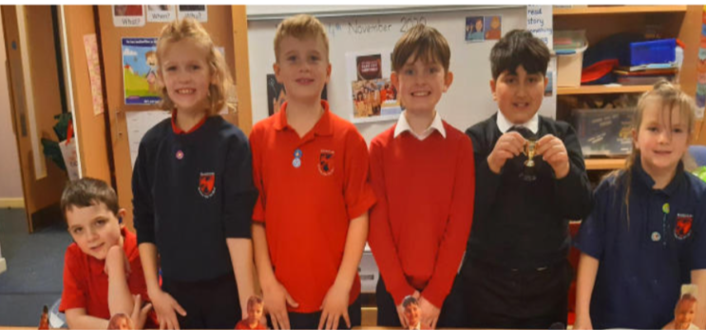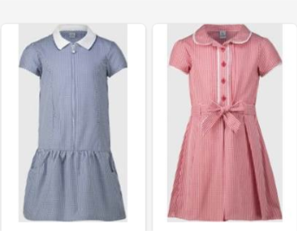

Clothing
We have access to a ‘Nearly New’ clothing bank of clothes donated by staff and families across the Hamilton and Glenlee campus. This is extended to include seasonal clothing such as winter jackets, party dresses/shirts/jumpers around November/December and pre-loved Halloween Costumes in October. All pupils are taxied into school each day which minimises the contact we have with our families, however we have close, positive relationships with our families which consists of regular two-way communication which allows us to provide clothing to those who require it.

Travel
Most of our children live out with the catchment area of the school, some travel from a different local authority. Our pupils travel to school using transport provided by their local authority. For those living within the catchment area, they choose to walk or are transported by family members. Any transport required for transitions or excursions are funded by the school. When afterschool clubs take place after school, we work in partnerships with transport and our families to ensure all learners have full access to any extracurricular events.

Learning
Children at Hamilton School for the Deaf do not need to pay for any core learning activities. All stationery is provided, and young people do not need to bring their own equipment. Any materials required for home learning is supplied to our families. We ensure all our learners have access to the digital technology required to complete set learning tasks. Our pupils have access to a variety of materials to promote ‘reading for enjoyment’. We have invested in ensuring our library reflects the needs of our learners and have recently increased our provision of books which include deaf characters. Pupils are encouraged to borrow texts to read at home with their families. We recognise our families do not live close to our school and work in collaboration with them to find the best way to share regular updates about their child’s learning, embracing digital technology to limit traveling expenses incurred when attending meetings in school. We aim to film events and upload these to YouTube so all families have access to their child’s performance where travel may be an issue.

Audiology
Daily audiological checks take place in school where batteries and tubing can be replaced at no additional cost to our families. This limits family travel expenses incurred to and from audiology clinics. We work closely with our Educational Audiologist to ensure we have the appropriate materials required to ensure hearing aids and additional equipment are well maintained. We have provided Roger Touch Screen microphones and receivers to provide the best access to spoken word at no additional cost to our families. Any equipment required from Crosshouse Hospital is posted out to families directly.

Communication
We recognise the support our families require in acquiring and developing British Sign Language. Staff provide signed videos or appropriate links to British Sign Language vocabulary to support communication. We would not expect any of our families to have to pay to acquire or develop their BSL skills and would direct families to the NDCS Family Sign Programme and through our own free BSL sessions in school.

Friendships
At Hamilton School for the Deaf, we pride ourselves on the strong relationships we have with our families, children and young people. Staff are skilled in providing nurturing, pastoral care and have an in-depth knowledge of our children to ensure that we meet the holistic needs of our learners. We will continue to teach young people about poverty related issues as part of our Health and Well Being curriculum through whole school and stage assemblies and the promotion of our nurturing ethos. We provide opportunities for our learners to meet with deaf peers from across Scotland and beyond with our ‘Signs Across the Sea’ initiative with a School for the Deaf in America. We will continue to gather views and opinions on ‘The Cost of the School Day’ and to involve children, families and staff in decision making around this.

School Trips
Currently our trips are planned each year in response to the learning and conversations within the classroom. All trips are funded by the school, so no cost is passed on to our families. Our Participatory Budgeting also voted to use an allocation of our money towards reducing the cost for opportunities for our learns to meet with deaf peers from across the country. Our children have the opportunity to attend various events throughout the school year which are fully funded by the school e.g., Deaf Football event in Kilmarnock, Deaf Service in Glasgow, visits to meet other deaf peers either at their school or in a mutually agreed venue, accessible pantomime and art performances. The transport for all of these activities is provided free of charge. As of session 22/23, our P6/7 pupils will attend a three-day residential experience which will be funded by PEF at no cost to our families. Our P7 pupils attend a residential event with their mainstream peers in Glenlee. The number of days was reduced from 5 to 3 and is now booked during quieter months to reduce costs. Parents are able to pay the cost of the trip in instalments over 12 months and pupils who receive Free School Meal entitlement and / or reside in SIMD deciles 1 or 2 can receive financial support. If any other family requires the support of the school to enable them to attend, we would cover the costs. The centres used provides all specialist clothing and equipment, so no extra cost is incurred.

Period Poverty
Within the school, there are sanitary products for all to access to tackle period poverty. The products are positioned in the girls’ toilet and the disabled toilet to provide discrete access to all. Free products are given out annually to all girls during the RSHP lessons if/when required. When South Lanarkshire Council teamed up with Hey Girls to offer free period products to all South Lanarkshire residents who needed them, regardless of income or personal circumstances, we communicated this to all our families. This allowed all families to order free period products to be delivered directly to their home.

Eating
All our learners are entitled to Free School Meals. Due to the introduction of ParentPay, we feel there is no stigma associated with a free lunch. Our pupils have the option to attend the Glenlee Breakfast Club that runs from 8.15 to 8.45 each day. This facility is free and ensures children attending have access to a healthy breakfast, physical and creative play daily. At the start of each day, everybody is offered warm, buttered toast and fruit. We always have a supply of fresh fruit for anyone who requires it. When celebrating events such as birthdays and cultural events, we provide all food and drink at no additional cost to families. If families require support in providing food for their family, the school will provide support through referral to appropriate agencies e.g., local foodbank, community links etc. Special diets, related to allergies and religions, are catered for.

Fun Events and Clubs
Hamilton School for the Deaf recognise that events planned for enjoyment can put added pressure on to families. As with school trips, our fun events and any clubs are free of charge to our families. Over the course of the year, all children take part in swimming, outdoor learning experiences and food technology experiences, which are completely funded by the school. We currently fund raise by having our Christmas Sign-a-long across the local community to subsidise the cost of the school day for our families.

Home Learning
We try to reduce the cost of learning at home as much as possible by providing all materials when required. This ensures that all pupils, no matter their family circumstances, can complete any homework activity. We recognise the immense effort and concentration required by our pupils to get through a school day and the wellbeing of our families is of great importance to us, therefore homework is not linked to our Positive Relationship policy.

Review
We are very clear that ‘The Cost of the School Day’ is an area that requires a constant focus and will strive year on year to ensure it is central to all school developments and improvements, involving our families, learners and staff.

Free School Meals
Children of parents who receive the following benefits are entitled to a free lunchtime meal for their child

- Income Support, Universal Credit, (where your take home pay is less than £610 per month), Job Seeker’s Allowance (income based), Employment and Support Allowance (income related), Working Tax Credit and Child Tax Credit (where your gross annual income does not exceed £6,420 as assessed by the HM Revenues and Customs), Child Tax Credit Only (where your gross annual income does not exceed £16,105 as assessed by the HM Revenues and Customs) or receive support under Part VI of the Immigration and Asylum Act 1999.

We would encourage parents of children who are in receipt of any of the above benefits to take up this opportunity of having a meal provided for their child when they are at school. Arrangements are in place so that children who receive free meals are not singled out and we encourage all children to remain in school at lunch time.

Healthy eating is something that the school supports and a range of meals are available at lunchtime that meet the Schools (Health Promotion and Nutrition) (Scotland) Act 2007 and the Nutrient Requirements for Food and Drink in Schools (Scotland) Regulations 2008.

All meals include fresh chilled drinking water and milk will be available for those pupils entitled to free school meals through the free school meal eligibility scheme at morning break or lunchtime.

All children at Hamilton School for the Deaf Nursery and Primary are provided with a free lunch.

Milk and toast is available free of charge to all children and is provided by the establishment.

South Lanarkshire Council provides fruit to P1 and P2 children 3 days per week to a selection of schools within the South Lanarkshire area.

School uniform

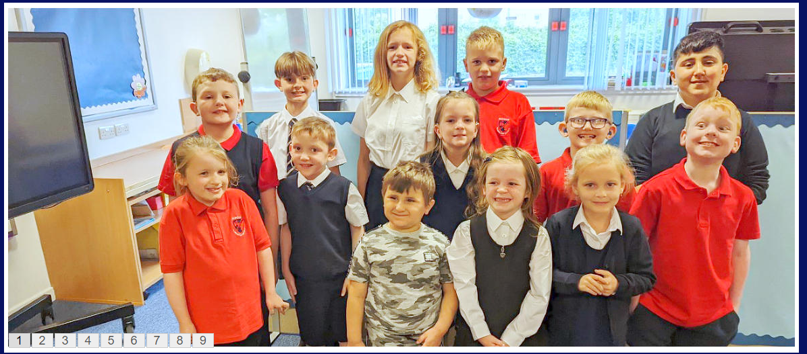

We ask all parents/carers to support the school by encouraging your child(ren) to adhere to the agreed dress code and the wearing of our school uniform. The wearing of a school uniform helps promote the identity of the school in the local community and helps create an ethos of sharing and pride in the school.

In addition, the wearing of a uniform helps towards increasing the protection of all pupils. The wearing of a uniform helps staff and the pupils to distinguish between who belongs to the school and those who may be visitors. This enables staff to approach and identify visitors more readily and helps in trying to offer a safer environment for pupils and teachers alike.

Our school uniform consists of:

- Either a white shirt and school tie or red polo shirt
- Black trousers/skirt
- Navy sweatshirt
- Soft shoes for indoor use

Equality of opportunity is an important aspect of the life of the school. Any proposals on the dress code and on what constitutes the school uniform will be the subject of discussion with Parent Council (if established) and where appropriate consultation with parents, pupils and staff.

There are forms of dress which are unacceptable in all schools such as:

- the wearing of football colours
- clothing with slogans that may cause offence (anti-religious, symbolism or political slogans)
- clothing which advertises alcohol, tobacco or drugs
- clothing which can be deemed unsuitable in terms of health and safety grounds such as shell suits, combat style clothing, dangling earrings, loose fitting clothes particularly in practical classes
- articles of clothing that could be deemed to inflict damage on other pupils or be used by others to do so
- footwear that may damage flooring.

If you require any support with clothing throughout the year, please contact me directly where we will support families discretely.

Allergies

We are a nut free school.

A significant number of children and young people in our schools will have allergies and it is important that parents keep the school fully informed on these matters.

Allergies can present in a variety of ways and can occur at any point in a person’s life. Symptoms range from mild to severe. Children and young people known to have an allergy with moderate to severe symptoms will likely have a Health Care Plan drawn up by the NHS. This will detail symptoms and appropriate interventions.

It is vital that parents share this information with the school and continue to provide any updated information.

Where symptoms are mild and a Health Care Plan is not in place, parents should continue to liaise regularly with the school on any new triggers, medications and actions required.

In all cases, our employees need to know your child’s symptoms, treatments and any actions required to help prevent exposure to the allergen and minimise the risk of allergic reactions.

Employees in schools will receive training on allergies and will liaise with parents and NHS on any additional specialist training required.

In supporting children and young people with allergies, school employees will operate in accordance with South Lanarkshire Council Safe Systems of Work / risk assessment and national guidance on the administration of medicines.

Support for parent/carers

Clothing grant
In certain circumstances the Council provides support to parents/carers for the purchase of school wear.

Applications can be made online at www.southlanarkshire.gov.uk. If you are required to submit evidence of your Tax Credit income it is important that a copy of this evidence is attached to your online application. Should you require further information, or you are unable to submit an application online then please contact the helpline number 0303 123 1011 (option 5).

Hamilton School for the Deaf School Hours

Opening 08:50
Interval 10.30 – 10.45
Lunch 12/12.15 pm – 13.00
Closing 14:50

Please note that the children are allowed access to the school building at 8:50. Prior to this they will remain with their taxi escorts.

See attached list showing school holiday dates.

Enrolment – how to register your child for school

If your child is starting school for the first time you must enrol your child at their catchment school in January. If parents want their child to go to another school, they must enrol in the first instance with their catchment school and ask for an information leaflet that provides details on how to make a placing request. Forms are available from the SLC website – www.southlanarkshire.gov.uk, schools, Q and A offices or by contacting Education Resources, Almada Street, Hamilton, telephone 01698 454102. Completed forms should be returned as soon as possible to Education Resources, Almada Street, Hamilton ML3 0AE.

Enrolment date for 2023 is week commencing 16th January 2023.

Please see Page 7 of this handbook for information on placement at Hamilton School for the Deaf.

Transport
South Lanarkshire Council has a policy of providing school transport to primary pupils who live more than one mile by the recognised shortest walking route from their catchment school. This policy is more generous than the law requires. This means that the provision of transport could be reviewed at any time. Parents who consider they are eligible should obtain an application form from the school or Education Resources, Hamilton, telephone 01698 454102 or web www.southlanarkshire.gov.uk. These forms should be completed and returned before the end of March for those pupils starting the school in August to enable the appropriate arrangements to be made. Applications may be submitted at any time throughout the year and will be considered by Education Resources.

A paid privilege transport scheme is operated for mainstream school contracts where a pupil is not entitled to free school transport. Privilege transport will only be granted providing there is spare capacity on an existing school contract and will be from and to designated pick up and drop off points. Privilege transport will not be provided where a service bus is used on the school run. Any spare capacity will be allocated using agreed priorities. For more information on school transport contact Education Resources telephone 01698 454102.

(ii) Pick-up points

Where school transport is provided it may be necessary for pupils to walk a certain distance to the vehicle pick-up point. Walking distance in total, including the distance from home to the pick-up point and from the drop-off point to the school in any one direction, will not exceed the authority’s distance limit for school transport.

It should be noted that it is the parent’s responsibility to ensure their child behaves in a safe and acceptable manner while travelling in and alighting from the vehicle. Misbehaviour can result in your child losing the right to school transport.

Parents are asked to note that South Lanarkshire Council does not provide transport for those pupils who attend school via a placing request. Where there is a request to place a child under school age in a school within the local catchment area, they may receive transport in line with the Council’s transport policy.

See page 7 for specific details for HSD transport to school.

Insurance for schools – pupils’ personal effects
South Lanarkshire Council is concerned at the level of claims being received for loss or damage to pupils’ clothing or personal effects. Parents are asked to note the Council’s position in terms of insurance for pupils’ personal effects:

(i) Theft/loss of personal effects

The Council is not liable for the loss or theft of pupils’ clothing or personal effects and any items are therefore brought into the school at the pupil/parents’ own risk.

Parents can assist by ensuring that valuable items and unnecessarily expensive items of clothing are not brought to school.

Teachers and other staff have been advised not to accept custody of any such items.

The same principle applies to musical instruments and other equipment used for activities within the school, which belong to the pupil, but are brought into the school. Parents should be aware that if such equipment is left in school, it is done at the pupil/parents’ own risk.

In the case of valuable items such as musical instruments, parents should ensure that these items are covered by their own household insurance.

(ii) Damage to clothing

The Council is only liable for damage caused to pupils’ clothing where the damage has resulted from the negligence of the Council or one of its employees. Claims arising otherwise will not be accepted by the Council’s insurers.

Family holidays during term time
Every effort should be made to ensure that your child attends school during term time. Please contact the school as soon as possible if your child is unable to attend school.

Family holidays should be avoided during term time as this both disrupts the child’s education and reduces learning time. If holidays are taken during times when the school is open parents should inform the school in advance by letter/ e-mail.
In Hamilton School for the Deaf it is often easier for Deaf parents to speak personally with staff. This should be done by a pre-arranged meeting either face-to-face or online.

If your child is taken on a family holiday during term time, then in line with Scottish Government advice, this will be classified as an unauthorised absence. However, in exceptional circumstances schools may register a family holiday during term time as an authorised absence when for example, parents are unable to obtain leave during the school holiday period.

Clearly, absence with no explanation from parents will mean that the absence will be recorded as unauthorised.

In our approach to raising attainment and achievement it is recognised that attendance at school is something that should be continuously encouraged. Parents/carers, children and the school all have a part to play in encouraging and stressing the importance of attendance at school.

The school holiday dates and in-service dates are available from the website www.southlanarkshire.gov.uk

Promoting positive behaviour
It is the responsibility of staff within the school to ensure that parent council members, parents and pupils are involved in the creation of a positive school ethos that encourages good behaviour. Equally, the school whilst trying to promote positive behaviour must support young people should incidents or bullying occur. Parents have a significant role to play in working with the school so that teachers, parents and pupils know what is expected of them in trying to change the behaviour and attitudes that contribute to bullying behaviour.

Our approach is to create an environment where better behaviour will encourage better learning. The school, along with the support of parents, can work together to create a learning environment which young people can enjoy and feel safe.

Incidents of bullying should be reported to the school immediately so that each alleged incident can be looked at. Together we can work towards creating a safer school for children and staff.
At HSD every reported incident will be investigated and dealt with in an appropriate manner.

In addition, a guideline (Management of Challenging Behaviour) has been produced to support all teaching and support staff and inform them of their roles and responsibilities in respect of dealing with the small number of children and young people who display challenging behaviour. Early identification is crucial so that intervention can be provided to support children and young people to help them address their issues and concerns. Staff training is provided to help develop the skills needed to respond to and manage challenging behaviour. A wide range of appropriate staff development opportunities has been developed for this purpose.

Child Protection
We are ‘Keeping The Promise’. The Promise is built on five foundations of voice; family; care; people and scaffolding. These foundations are at the heart of our promise for our children and families.
At its core, the commitment to keep children with their families where it is safe to do so and above all else, value the importance of relationships with families. We are working to shape local practice and involve service providers, professionals and volunteers involved in the lives of children to implement change.

All staff in educational establishments in South Lanarkshire Council are required to receive an annual update and follow the advice and guidance contained within the Education Operating Procedures.

The shared vision for Lanarkshire’s children is: “all children and young people in Lanarkshire have the right to be cared for and protected from abuse and harm in a safe environment in which their rights are respected.” All agencies will work together in a collaborative way to promote the safety and wellbeing of children and young people in Lanarkshire.

The Chief Officers and Child Protection Committees of North and South Lanarkshire Council’s are the driving force for ensuring that agencies individually and collectively work to protect children and young people as effectively as possible.

The Council has a duty in law to report suspicions that a child has been abused or is at risk of harm, in terms of the Children (Scotland) Act 1995. Therefore, Council staff have a professional and contractual obligation to report concerns to the head of establishment or the child protection coordinator immediately.

Education Resources staff and visitors from other agencies and services are required to follow these Child Protection Procedures to protect and support children and to fulfil their professional obligations to report all allegations or suspicions of child abuse.

For more information, or if you have a concern of a child protection nature, please contact the head of the educational establishment which your child attends.

The Council has produced an information leaflet – ‘stay safe’ for parents/carers on how to help ensure their child is safe when using the internet and mobile devices.
Copies are available from the school or the web: www.southlanarkshire.gov.uk

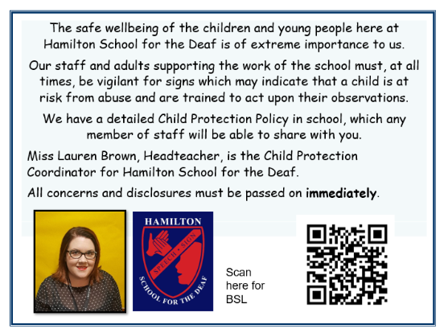

Information on emergencies
We make every effort to ensure the school remains open during term-time for pupils. However, on occasions circumstances may arise which can affect the school. Schools may be affected by, for example, severe weather, power failures or through any other circumstances that may impact on the school day. In such cases we shall do all we can to let you know if this happens. We shall keep you in touch by telephone, text, where appropriate, letters, web news and through local radio stations particularly if there are prolonged periods of severe weather. The Council’s website www.southlanarkshire.gov.uk will be used to let you know if the school is closed and when it will re-open.

It is very important for parents/carers to let the school know of any change to your mobile/home telephone number and change of address.

If for any reason, you are unsure if the school is open, please contact the school or Education Resources, Operations Service, Almada Street, Hamilton. (Telephone 01698 454545) or email us at: education@southlanarkshire.gov.uk or visit the website www.southlanarkshire.gov.uk

Your commitments
We ask that you:

- support and encourage your child’s learning
- respect and adhere to the school’s policies and guidance
- let the school know if you change your mobile/telephone number and/or address
- enjoy and take part in school activities
- accept your responsibility to respect staff who work in the school and for the school to be proactive in taking forward its commitment to care for and educate your child.

Data Protection Act 1998
Information on pupils, parents and guardians is held by the school to enable the teaching, registration and assessment of pupils as well as associated administrative duties. The information is stored and used as per the requirements of the Data Protection Act 1998 with South Lanarkshire Council defined as the data controller. The Council have established a data protection policy that applies to all schools. For more information, please contact the school.

School Holidays for Session 2023/24
Types of holiday listed by month | Holiday dates
August 2023
Teachers return on Monday 14 August 2023
In-service days - all schools | Monday 14 and Tuesday 15 August 2023
Pupils return to school | Wednesday 16 August 2023
September 2023
September weekend | Friday 22 and Monday 25 September 2023
October 2023
October break | Monday 16 to Friday 20 October 2023  Pupils return on Monday 23 October 2023
November 2023
In-service day - all schools | Monday 13 November 2023
December 2023 and January 2024
Christmas/New Year | Schools close at 2.30pm on Friday 22 December 2023  Schools re-open on Monday 8 January 2024
February 2024
February break | Monday 12 and Tuesday 13 February 2024
In-service day - all schools | Wednesday 14 February 2024
March/April 2024
Spring break/Easter | Schools close at 2.30pm on Thursday 28 March 2024*  Schools re-open on Monday 15 April 2024
May 2024
In-service day - all schools | Thursday 2 May 2024
May day | Monday 6 May 2024
Local holiday | Friday 24 and Monday 27 May 2024**
June 2024
Summer break | Schools close at 1pm on Wednesday 26 June 2024
* Good Friday falls on Friday 29 March 2024
** Lanark schools will close on 6 and 7 June 2024
Pupils attend school for 190 days and teachers attend for 195 days.


Education Resources

Contact Details

Education Scotland’s Communication Toolkit for engaging with parents

The Scottish Government guide Principles of Inclusive Communications provides information on communications and a self-assessment tool for public authorities

Choosing a School: A Guide for Parents - information on choosing a school and the placing request system

A guide for parents about school attendance explains parental responsibilities with regard to children’s attendance at school

Parental Involvement
Guidance on the Scottish Schools (Parental Involvement) Act 2006 provides guidance on the act for education authorities, Parent Councils and others

Parentzone provide information and resource for parents and Parent Councils

School Ethos
Supporting Learners - guidance on the identification, planning and provision of support

Journey to Excellence - provides guidance and advice about culture and ethos

Health and wellbeing guidance on healthy living for local authorities and schools

Building Curriculum for Excellence Through Positive Behaviour and Relationships outlines the Scottish Government’s priority actions around positive behaviour in schools and is also a source of support

Scottish Catholic Education Service’s resource ‘This is Our Faith’ which supports the teaching and learning of Catholic religious education

Curriculum
Information about how the curriculum is structured and curriculum planning

Information about the outcomes a learner can expect to experience and achieve across literacy, numeracy and health and wellbeing, as well as the 8 curricular areas

Advice, practice and resources to support the experiences and outcomes on literary, numeracy and health and wellbeing

Broad General Education in the Secondary School – A Guide for Parents and Carers

Information on the Senior Phase

Information on Skills for learning, life and work

Information around the Scottish Government’s ‘Opportunities for All’ programme

Information for organisations responsible for the planning, management and delivery of career information, advice and guidance services

The Skills Development Scotland website ‘My World of Work’ offers a number of tools to support career planning

Assessment and Reporting
Building the Curriculum 5: a framework for assessment provides guidance around the assessment framework

Information about Curriculum for Excellence levels and how progress is assessed

Curriculum for Excellence factfile - Assessment and qualifications

Information on recognising achievement, reporting and profiling

Transitions
Curriculum for Excellence factfile - 3-18 Transitions - provides information on the transitions children and young people will face throughout their education and beyond

Career Information, Advice and Guidance in Scotland - A Framework for Service Redesign and Improvement provides guidance on career information, advice and guidance strategy

Choices and changes provide information about choices made at various stages of learning

The Additional support for learning page provides links to relevant legislation and guidance, including the arrangements that should be in place to support pupils with additional support needs

Supporting Children's Learning Code of Practice includes specific requirements on education authorities and others under the new legislation in relation to transition

Enquire is the Scottish advice service for additional support for learning

Parenting Across Scotland offers support to children and families in Scotland

National Deaf Children’s Society

Support for Pupils

The Additional support for learning page provides links to relevant legislation and guidance, including the arrangements that should be in place to support pupils with additional support needs

Information about the universal entitlement to support that underpins Curriculum for Excellence

Supporting Children's Learning Code of Practice (Revised edition) - provides Statutory guidance relating to the Education (Additional Support for Learning) (Scotland) Act 2004 as amended

Getting It Right For Every Child and Young Person, is essential reading for anyone involved or working with children and young people, including practitioners working in adult services with parents and carers

National Deaf Children’s Society

School Improvement

Scottish Schools Online - provides a range of school information, including contact details, school roll, facilities, website, inspection reports

Education Scotland’s Inspection and review page provides information on the inspection process

The Scottish Survey of Literacy and Numeracy (SSLN) is an annual sample survey which will monitor national performance in literacy and numeracy

Scottish Credit and Qualifications Framework (SCQF)

Scottish Qualifications Authority provides information for teachers, parents, employers and young people on qualifications

Amazing Things - information about youth awards in Scotland

Information on how to access statistics relating to School Education

School Policies and Practical Information

National policies, information and guidance can be accessed on the following:

Education

Health

Young People

Children (Scotland) Act 1995

Standards in Scotland's Schools (Scotland) Act 2000

