Hamilton School for the Deaf
Standards and Quality Report 22/23
Context of the school:
Our School:
Hamilton School for the Deaf is situated in Anderson Street, Hamilton in South Lanarkshire. Our school comprises of a specialist Nursery, specialist Primary and our Outreach Department. Across our Nursery, Primary and Outreach service, most staff are qualified Teachers of Deaf Children and Young People, with others in training. Most staff have achieved level 2 BSL with some staff achieving BSL level 6. Staff are continuously striving to improve our BSL skill set.
Nursery and Primary School
The nursery and school take in children from throughout North and South Lanarkshire and all children come by special transport arrangements. Our school is on a shared campus with Glenlee Primary. Both Glenlee and Hamilton School for the Deaf Nurseries share the nursery environment in a fully inclusive manner. A Total Communication approach is embraced in Hamilton School for the Deaf where we value all modes of communication, respectfully. The languages used within the school are BSL and English. Currently our school roll is thirteen children ranging from Nursery to P7. Within our nursery we have a highly specialist Early Years Practitioner who has years of experience supporting young deaf learners. Time is taken each day to carry out audiological checks and to provide focused 1:1 input through a Total Communication approach, in a quiet listening environment to further develop language and communication skills. Within the primary school we have three classrooms, a sensory room and access to all resources within the campus including a large gym hall, stage, dinner hall, IT Suite and Nurture Room. Hamilton School for the Deaf work in partnership to provide inclusion and reverse inclusion with Glenlee Primary when appropriate, while still maintaining small class sizes (up to 6 children) to allow intensive language acquisition. It is important that pupils have full access to all extracurricular activities available in the joint campus and for this reason we endeavour to organise special transport arrangements to allow pupils to take part in clubs and activities after school. The aim of Hamilton School for the Deaf is to provide our pupils with a safe, nurturing environment where they can have full linguistic access to the curriculum which allows them to achieve at least in line with their hearing peers. We aim to provide our children with a curriculum which fosters the development of a positive Deaf identity and language proficiency which enables them to play as full a part as possible in both Deaf and hearing communities. We have strong links with our parents, this session we were able to invite our parents and families back into school after two years of remote communication. We are proactive in our approach to communicate regularly with our parents using Google Classroom, e-mail, text messaging and online meetings. In the early years, we share daily feedback with our parents to keep parents fully informed.
We are part of Calderside Learning Community and have links with local schools. We also have strong links with other schools for the deaf and resource bases throughout central Scotland and we plan to re-establish the good practice of meeting regularly with them as we move away from Covid restrictions.
Outreach Service
The Outreach Service provides support to 210 deaf children within South Lanarkshire, aged 0-18 years. Our visiting Teachers of Deaf Children and Young People support children in their local or ASN nursery, primary and secondary setting. Our service carries out initial assessments in consultation with parents/carers and all other relevant professionals and agencies to build a holistic profile of each learner. Our Teachers of Deaf Children and Young People then provide 1:1 focused teaching time to develop language, concept development, listening skills, independence in audiological management and provide Deaf Awareness training to educational establishments across South Lanarkshire. The level of support is based on need and is reviewed regularly. Our Teachers of Deaf Children and Young People are involved in the setting of targets for Additional Support Plans and attend any relevant meetings to ensure the rights of the deaf learner are advocated. During times of transition the Outreach Service are instrumental in ensuring new establishments are fully informed of the needs of the learner and provide additional support to the learner and establishments during such times. We have established strong links with Educational Audiology, NHS Audiology and Speech and Language Therapists to ensure we deliver a coherent approach in meeting each learners’ needs.

Review of progress for session Aug 2022- June 2023
The following report outlines the work of Hamilton School for the Deaf in our efforts to address National, Local and Deaf Education priorities.

National Priorities
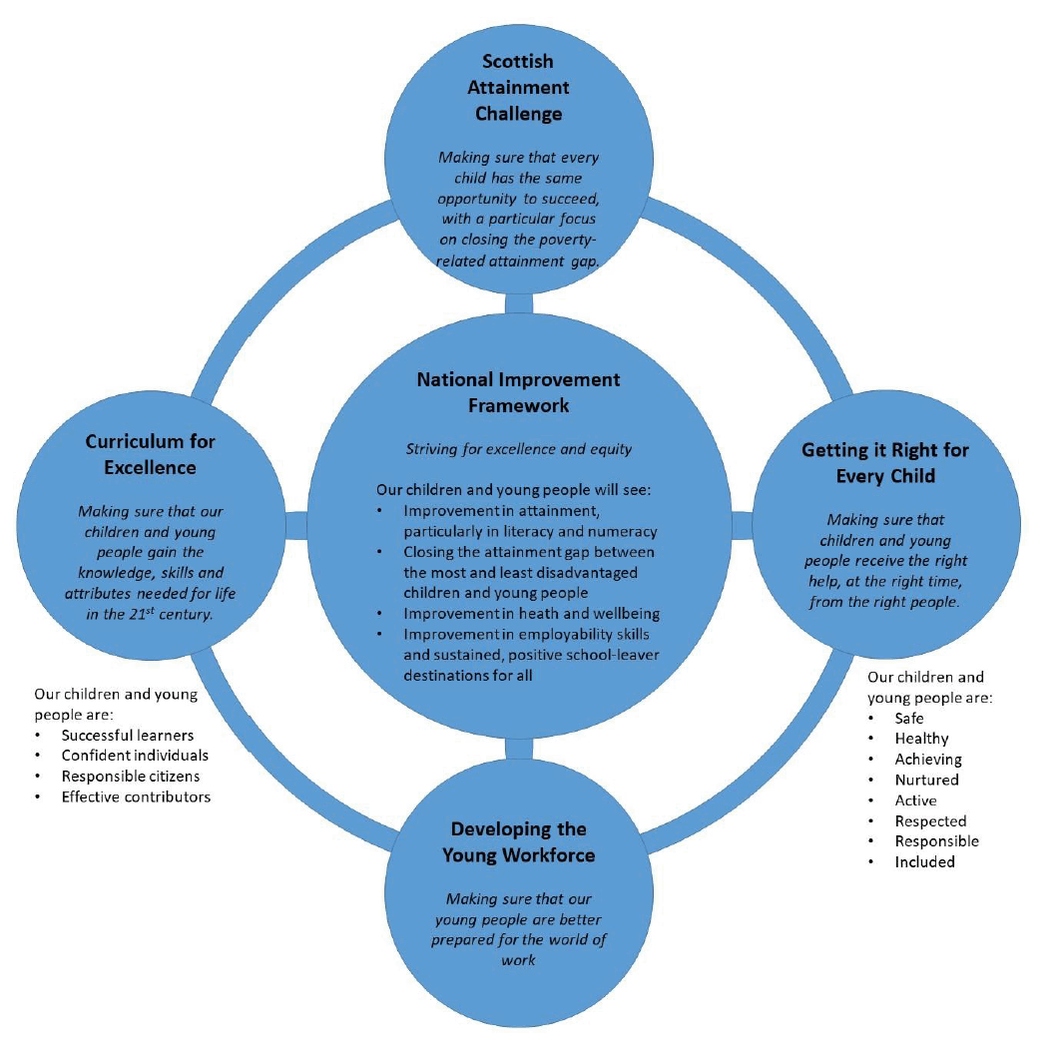

Local Priorities
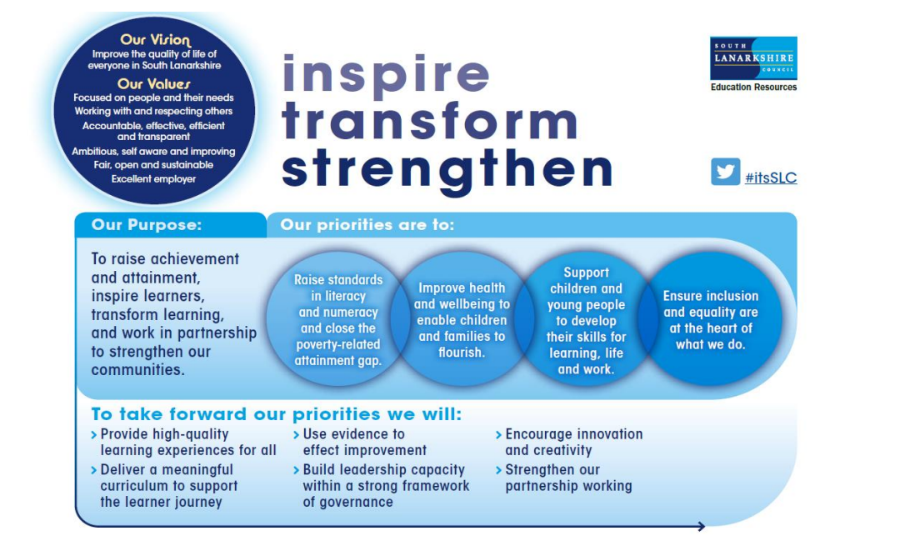Deaf Education Priorities
The impact of deafness can vary considerably and can be dependent on individual differences, early language experiences and additional disabilities. 40% of deaf children also have other additional support needs. Regardless of the severity of hearing loss, deafness can impact on communication, learning and social development. Deaf people who are British Sign Language users are almost twice as likely to have mental health issues compared with the general population (40% against 25%). In addition, people with mental health and deafness issues (multiple needs) often face marginalisation from mainstream society. There is a great deal of stigma attached to mental health within the Deaf community, thus leading to isolation and loneliness in a close-knit community. The British Sign Language (BSL) National Plan for Scotland drives the work of the school as we aim to meet the target of ensuring learners who use BSL will get the support they need at all stages of their learning, so that they can reach their full potential.
To understand and advocate the communication needs of deaf learners and promote British Sign Language to ensure inclusion and equity and improve wellbeing.
To support and promote a culture and ethos where deaf learners, parents and families understand their rights, thrive and succeed.
To support transitions to allow deaf learners in early learning and schools to thrive and succeed.
To provide Deaf Studies as part of the curriculum to develop a positive deaf identity and improve wellbeing.

School Priorities
Improve access to spoken language through better audiology provision. | Improve and support health and wellbeing of our deaf learners. | Improve Deaf Awareness across South Lanarkshire educational provisions.
Raise standards in literacy. | Raise standards in language and communication. | Raise standards in numeracy.
Improve BSL skills across the school community. | Raise awareness of the world of work and skills for life through provision of positive deaf role models. | Actively work in partnership to meet deaf learners’ needs and support deaf children/ young people, their families and their educational establishments across South Lanarkshire during times of transition.

SLT
Theme: Leadership
HGIOS4 QIs: 1.3 Leadership of Change
Assertion | Increased leadership at all levels across the school community.
Action | Sharing research on the impact of leadership at all levels. Recognising staff were looking to further develop leadership skills. Staff already accountable for areas but not formally recognised.
Challenges | Encouraging all staff to take responsibility for an area of responsibility.  Staff confidence and understanding of ‘leadership’ at all levels.
Impact (evidence) | 100% of staff now accountable and leading on a variety of different themes across Hamilton School for the Deaf.  Increased opportunities for CPD and networking across SLC.  Improved awareness of SLC initiatives and resources through networking to improve learning and teaching.  Devolved leadership across school to ease pressures on Head Teacher.  Increased confidence in most staff in leadership skills.  Improved communication and timely support as key people identified for specific areas e.g. Nurture, Early Years, Equity.
Next steps | Review areas of ‘leadership’ as some do not suit the remit currently held and some a ‘lighter’ areas of responsibility than others.  Continue to build in time at whole staff meetings for update from all.

Theme: Leadership
HGIOS4 QIs: 1.3 Leadership of Change
Assertion | Increased leadership at all levels across the school community.
Action | Sharing research on the impact of leadership at all levels. Recognising staff were looking to further develop leadership skills. Staff already accountable for areas but not formally recognised.
Challenges | Encouraging all staff to take responsibility for an area of responsibility.  Staff confidence and understanding of ‘leadership’ at all levels.
Impact (evidence) | 100% of staff now accountable and leading on a variety of different themes across Hamilton School for the Deaf.  Increased opportunities for CPD and networking across SLC.  Improved awareness of SLC initiatives and resources through networking to improve learning and teaching.  Devolved leadership across school to ease pressures on Head Teacher.  Increased confidence in most staff in leadership skills.  Improved communication and timely support as key people identified for specific areas e.g. Nurture, Early Years, Equity.
Next steps | Review areas of ‘leadership’ as some do not suit the remit currently held and some a ‘lighter’ area of responsibility than others.  Continue to build in time at whole staff meetings for update from all.

Theme: Leadership
HGIOS4 QIs: 1.3 Leadership of Change
Assertion | There is full commitment from all staff to the shared educational values, vision and aims and self-evaluation against professional standards within Deaf Education to identify good practice and areas for development.
Action | Sharing research on the impact of leadership at all levels. Recognising staff were looking to further develop leadership skills. Staff already accountable for areas but not formally recognised.
Challenges | Encouraging all staff to take responsibility for an area of responsibility.  Staff confidence and understanding of ‘leadership’ at all levels.
Impact (evidence) | 100% of staff now accountable and leading on a variety of different themes across Hamilton School for the Deaf.  Increased opportunities for CPD and networking across SLC.  Improved awareness of SLC initiatives and resources through networking to improve learning and teaching.  Devolved leadership across school to ease pressures on Head Teacher.  Increased confidence in most staff in leadership skills.  Improved communication and timely support as key people identified for specific areas e.g. Nurture, Early Years, Equity.
Next steps | Review areas of ‘leadership’ as some do not suit the remit currently held and some a ‘lighter’ area of responsibility than others.  Continue to build in time at whole staff meetings for update from all.

Nursery and Primary Department

Theme: Wellbeing
HGIOS4 QIs: 3.1 – Ensuring wellbeing, equality and inclusion
Assertion | Supporting learners through loss and change
Action | Seek out training/support materials for supporting pupils who are experiencing grief – Give Us A Break (GUAB)
Challenges | Adapting resources to suit needs of Deaf learners  Finding appropriate GUAB group and co-facilitator  Age-range suitability of GUAB resources (10-14 years)
Impact (evidence) | HSD staff completed GUAB facilitator training  GUAB group established within campus – HSD pupil attending group with support from HSD staff  Pupil becoming more confident when identifying and discussing feelings related to bereavement.  Pupil is becoming aware that other children can have similar feelings and experiences.  Solution focused approach is allowing pupil to identify strengths and set goals for the future.
Next steps | Seek out resources/support materials for younger children who are experiencing loss and change.

Theme: Numeracy
HGIOS4 QIs: 2.4 – Personalised Support
Assertion | Introduce dyscalculia assessment and support materials
Action | Implement dyscalculia assessment resources.  Use assessment results to implement targeted intervention, bespoke to learner, using dyscalculia support materials.
Challenges | Sourcing appropriate assessment materials  Time to complete assessment and 1:1 activities
Impact (evidence) | Assessment resources for number sense and counting, calculation and place value completed with learner to establish areas of difficulty within these areas.  Targeted intervention implemented with learner using dyscalculia support materials.  Learner engagement and confidence in numeracy tasks greatly improved.  Sample resources sent home to be used with family.
Next steps | Complete remainder of assessment with learner and implement appropriate support materials.  Identify other learners within the school who may benefit from assessment.

Theme: Language and Communication
HGIOS4 QIs: 3.1
Assertion | Improve opportunities for all pupils to communicate.
Action | Install Boardmaker software across the school.
Challenges | New login needed. Software needed reinstalled after ICT refresh.
Impact (evidence) | New login allows access to Boardmaker 7 on all PC’s in the school.  Juli Taylor and Lindsay Campbell attended workshop at West Mains to find out how to access Boardmaker 7.
Next steps | AAC/Communication lead at West Mains, Mrs Dawn Kean to offer further training if required.

Language and Communication
Assertion | Improve BSL receptive and production skills through focus on maintaining visual attention.
Action | Conduct yearly BSL production and reception assessments to track progress.  Introduce weekly signing and watching lesson to help pupils to watch for longer periods.
Challenges | Finding time to conduct BSL production tests is v challenging as it takes a significant amount of time to watch videos and allocate marks, identify targets and share with staff.  It was challenging to find time within the weekly literacy hours to focus on visual attention, however potential benefits to BSL and learning across the curriculum meant it was important to address.  Some children were struggling to pay visual attention to a short instruction as well as longer stories. This impacted on their learning.
Impact (evidence) | The children took part in weekly watching and retelling sessions which usually involved a signed story with developing drawings/visuals on the large white board.  The children all benefitted in different ways – some had previously been unable to watch for a complete sentence or instruction, by the end of the intervention they were able to watch a story for up to 15 minutes. The children then retold elements of the story to demonstrate their understanding and BSL production. One pupil, who found visual attention difficult due to autism, used residual hearing and benefitted from hearing structured stories and being shown that there was a beginning, middle and end.  Story vocabulary was introduced and copied. Children were able to watch with only the smallest reminder, provided they were well positioned and the stories included funny/scary/engaging elements.  Some pupils adapted and extended stories when retelling. Pupils were videoed to see progress/ identify individual targets, and provide evidence.  Children took part in activities to improve visual memory – e.g. looking at 4 shapes, covering, drawing in the correct order. Children were able to extend to include a series of numbers, letters and simple drawings; increasing the number they had to remember.
Next steps | Continue to provide opportunities for watching BSL stories, share method with other staff members who have pupils struggling with maintaining visual attention.  Consider ways to measure improvement over time (in collaboration with SaLT?)  Repeat BSL production and reception assessments to note progress. Select a BSL target for each pupil and share with teachers/BSL role model.  Watch TV programmes presented in BSL or with interpreter.

Language and Communication
Assertion | Explore options to create a more systematic/consistent approach to teaching English grammar.  Explore alternatives to ORT reading programme.
Action | When it comes to teaching grammar (including punctuation) and spelling, teachers are all using different methods, resources, plans etc. Look at other schools, resources, etc to select something that can track and monitor progress in this area across the school.
Challenges | Deaf pupils need a first language before they can be expected to produce written/spoken sentences using English grammar.
Impact (evidence) | Examples of grammar planners and trackers were sourced from other schools/services.  Other reading schemes explored.  Visited WP School to investigate how reading and writing was taught there, resources etc used. Observed lessons using Read, Write Inc.  Attended SL literacy coordinators meeting, noting that SL are about to put out grammar progression trackers. Made link with Glenlee Lit Coordinator to discuss issues.  Read write inc resources decided upon and ordered ready for 2023-24. This will provide us with an integrated approach to reading, phonics and writing – addressing our whole English programme to ensure consistency and clear tracking/progress.
Next steps | Look at SL grammar progression tracker to see if it will be useful to work alongside RWI.  All staff to receive training on RWI.  Begin to roll out RWI across the lower/whole school.  Review use of RWI at end of school year.

Theme: Wellbeing
HGIOS4 QIs: 3.1 - Ensuring Wellbeing, equality and inclusion
Assertion | Children to develop and use their emotional literacy in school.
Action | Implement emotions topic at beginning of the year  Implement daily emotional ‘check in’s’ for pupils
Challenges | Sourcing appropriate resource to base full topic around (found at local library)  Children not always keen to talk openly about their emotion check in choices.  Concrete recording of daily emotions
Impact (evidence) | Working through the topic allowed us to find a baseline of children’s emotional literacy at the beginning of the year and to build on their previous knowledge.  Children able to name emotions and discuss what these look and feel like to them in a small group.  Children able to relate different emotions to their own life experiences.  Children always keen to pick from their emotions board as part of their morning routine and to tell teachers what they had picked. This encouraged discussion in the class.  Introduced daily ‘check in’ on the iPad and this allows children to add a comment to give more details about how/why they are feeling. This allows us to have a conversation with them privately if it is a sensitive subject or something they want to talk about 1:1.  Children add comments more frequently on their daily check in and have become more able to discuss the reasons behind their feelings and how they/we can help if needed.
Next steps | Continue to use this as pupils move into new class.  Roll out throughout the school, where appropriate.  Source different emotional topic resources to allow staff to use at the beginning of year.

Theme: Deaf Awareness
HGIOS4 QIs: 1.2 – Leadership of Learning
Assertion | Staff and pupils in Glenlee inclusion classes should be Deaf Aware and staff should employ relevant strategies.
Action | Children to create Deaf Awareness Presentation to deliver to their inclusion class.  Children to deliver this presentation to their peers and mainstream class staff  Staff to use suggested strategies
Challenges | Timetabling to establish inclusion  Staff/children absences  Limited time to present
Impact (evidence) | Children able to decide what information about their deafness was important to pass on and what parts they wanted included in presentation.  Children created presentation with support from class teacher.  Children presented presentation to their mainstream class. Children and staff in the class asked questions during the presentation and HSD children answered all of these.  Staff using FM properly during PE sessions.  Staff using strategies during inclusion activities.
Next steps | Continue to do this with all inclusion classes each year.  Present these at campus assembly to ensure pupils not in inclusion classes have same information to allow them to be Deaf aware on campus.

Theme: Inclusion and equality
HGIOS4 QIs: 3.1 Ensuring wellbeing, equality and inclusion
Assertion | Children to be independent in hearing device maintenance and management and trained staff to support this with appropriate tools.
Action | Develop universal protocol for daily checks.  Encourage children to take full responsibility of daily handling. E.g. seeking their equipment at new period within a day.  Handing equipment to new teacher if staff changes occur.  Ensuring FM system is always connected.  Appropriate tools for staff to support their checks.
Challenges | Children with additional needs can find it problematic due to fine motor skills required and lack understanding of the importance of looking after their listening devices.  Expensive equipment required.
Impact (evidence) | Creates a sense of responsibility.  Ensures that every child has access to sound to maintain equality.  Increases confidence in early years to recognise phonemes and begin to distinguish between sounds/words/phrases/sentences.  Children can inform teachers if they become disconnected or their battery goes flat.  Teachers can recognise if their hearing aids don’t appear to look quite right and inform parents e.g. when a mould is split.
Next steps | To request a device from audiology, and begin to use, that will allow staff to listen through a Roger System to confirm cochlear implants are streaming sound consistently at the appropriate level, and to be able to recognise if the sound is ever degraded.  Request to purchase an Aurical HIT to measure hearing aid gains, so that they have appropriate gain provided for their hearing loss.

Theme: Engaging families in learning
HGIOS4 QIs: 2.5 Family Learning
Assertion | Encourage family engagement of the school
Action | To communicate with parents in their first language (BSL) using video messaging platforms
Challenges | Acceptance of parents being communicated via social media platform e.g. WhatsApp.  Using personal phone as school phone is not a SMART phone.
Impact (evidence) | More personal making the parent feel part of the school community.  Builds positive relationship with parents.  Keeps parents informed of their child's learning.  Timely communication.  Can explain homework tasks clearly to reduce pressure at home.  Good way for parents to share what they did at the weekend.
Next steps | Continue communication via video platforms to build trust and positive relationships so parents whose first language is BSL, can access all information in their own language.

Theme: Partnerships
HGIOS4 QIs: 3.1
Assertion | Re-establish ASPs for all pupils and include all wider agencies working with individual pupils.
Action | ASPs now established for all pupils and include all wider agencies working with individual pupils.
Challenges | Time constraints before Education Scotland inspection.
Impact (evidence) | ASPs are now in place and targets set each term.  Parents are sent evaluations and asked for home target.  Links with wider agencies are improving and strategies shared and used in class to support individual pupils eg. SaLT, Cochlear Implant Centre, Nurture Team at Glenlee PS.
Next steps | Await further guidance from SLC as ASPs are currently under authority review.  Continue to evaluate ASPs to ensure appropriate targets are set.  Continue to communicate with wider agencies and create links to new partnerships when required.

Outreach Department
Theme: Language development
HGIOS4 QIs: 3.2 Raising attainment and achievement
Assertion | - To develop vocabulary and improve reading skills through learning by sight, where appropriate
Action | - Producing visuals for key words associated with the ORT and Storyworld reading scheme  - Produce visuals associated with the North Lanarkshire spelling programme  - Produce visuals by categories  - All the above produced using the Bitsboard app and saved to OneDrive for accessibility by the whole team  - Providing resources for home use to allow further practice at home
Challenges | - Time constraints as very labour intensive  - Delegation across team to ensure equality
Impact (evidence) | - Improvement in receptive and expressive language levels which can be measured using language assessments  - Improvement in motivation of students and changes in attitude to schoolwork as learners start to feel success  - Improvement in reading levels and learners moving through the stages at a good pace  - Learners staying in groups and not having to work as individuals
Next steps | - Create visuals for the Fry Word lists  - Collate categories and produce visuals

Theme: Literacy
HGIOS4 QIs: 2.3
Assertion | All staff must create visuals, where required, to support phonics acquisition, reading development and vocabulary development.
Action | - Visuals for phonic acquisition resourced and a bank for all Early Literacy phonemes added to resources within Outreach Office.  - Visual folder added to bank of resources within Outreach.  - Colourful Semantics resources added to folder within Outreach and OneDrive.  - Colourful Semantics coded system used to build vocabulary and develop language structure.
Challenges | - Time to prepare resources – laminate / cut  - Budget – resources such as Velcro  - Access to visuals  - Vocabulary development – waiting on nursery / schools / parents to get in touch to allow resources to be prepared early.
Impact (evidence) | - Pupils like the phonic resources – they are bright and clear. Supports engagement throughout activity.  - CVC resource – children enjoy the ‘guessing’ element of the activity. Highlights if any difficulties accessing sounds – initial, end or vowel sounds. This can then be focussed on. Information shared with school / parents and links and support continued.  - Visuals support early language development. Supports child to have a choice of activity while verbal language is developing. Resources shared with class teacher and home. Display made within classroom to support child’s interactions in class. Teacher reported this is an effective communication mode for child within the class.  - News sharing – visuals support the child to share news. 2 / 3 word level sentences can be formed using familiar visuals to allow the child to share news from class and home.  - Shared resource with nursery to ensure continuity for child.
Next steps | - Develop an early language and communication plan to support tracking and monitoring of vocabulary introduced / acquired.  - Develop assessment checklist to track and monitor receptive and expressive language – English / BSL.  - Build on visuals to include topic vocabulary used within school and home.  - Support nursery / primary staff to use visuals to support child.

Theme: Well-being
HGIOS4 QIs: 3.1 Ensuring wellbeing, equality and inclusion
Assertion | - To develop self-advocacy skills in our pupils and help them to understand their rights around their deafness
Action | - Ordered El Deafo books for each member of staff  - Highlighted age and ability appropriate pupils  - Added to forward plans for the first term and supported pupils to read together and discuss the issues which arose
Challenges | - More difficult to put into practice with less frequently visited pupils
Impact (evidence) | - All pupils who worked on this book were fully engaged and motivated by the subject matter  - All commented about wanting to read more books with deafness as a subject  - Pupils able to relate to the character and some of her experiences, which opened dialogue about their own experiences. This helped to educate pupils on what they should not be accepting and develop pupil voice.  - This dialogue helped to inform their Personal Passport
Next steps | - Make resources/tasks around the book to help develop Pupil Voice (posters, PowerPoints, etc)  - Explore more Rights related material, around UNCRC in particular

Theme: Audiology
HGIOS4 QIs:
Assertion | Teaching school staff how to effectively check if a pupil is accessing Ling sound on a daily basis.
Action | - Deaf awareness provided to all school staff.  - Hearing aid maintenance / check training provided for class teacher and ASNA.  - Ling Sounds introduced and explained to staff.  - Audiology kit given to staff.  - Ling Sounds given to staff.
Challenges | - Time for staff to check aids / Ling sounds daily.  - Budget for equipment / replacements  - Staff absence.  - Use of aids at home
Impact (evidence) | - Increase in child’s use of aids.  - Confidence that aids are working and maintained within school.  - Head Teacher supports parent to engage in bringing aids to school. Building up to wearing at home.
Next steps | - Ensure all nurseries / schools provided with equipment for checking aids when appropriate.  - Ling Sounds – email to schools / provide copies for staff.  - Provide Ling Sounds for home, if appropriate.  - Support parents to maintain aids at home. Encouraging more consistent use.

Theme: Deaf Awareness
HGIOS4 QIs: 3.2 Raising attainment and achievement
Assertion | - To ensure equality at SQA level examinations for deaf learners
Action | - Created a policy document for all staff to use related to Alternative Assessment Arrangements at SQA level
Challenges | - Becoming familiar with the SQA guidelines and linking to the secondary curriculum.  - Lack of awareness of the secondary curriculum and how each subject is assessed
Impact (evidence) | - Equality for deaf learners in every high school in SLC  - More confidence in Outreach staff on the subject, which resulted in stronger relationships being built with the secondary staff  - Reduction in anxiety for deaf learners around their exams – separate quieter accommodation, extra time, etc
Next steps | - Make a document for all deaf learners starting at nursery level through to primary which specifically states appropriate alternative assessment arrangements  - Explore the format of SNSAs to allow us to advise specifically

Theme: Deaf Awareness
HGIOS4 QIs: 1:2 Leadership of Learning
Assertion | All secondary staff should be deaf aware, be confident users of radio aid technology and employ relevant strategies to support deaf pupils.
Action | Secondary Deaf Awareness to be rolled out and given a priority to yearly calendars.  Secondary Deaf Awareness arranged in final term for whole staff Lanark Grammar and Lanark Grammar ASN Base.  Deaf Awareness delivered to whole staff in August Inservice Day and feedback requested and received.
Challenges | Establishing positive working relations with Secondary Staff – this took some time as previously contact was irregular.  Limited to Inservice Days for whole staff training
Impact (evidence) | Feedback received was positive and staff reported training was beneficial.  Pupil reports Deaf Awareness strategies are employed by staff.  Staff requested we deliver similar deaf awareness training session for S1 year group.  Staff supportive of encouraging radio aid use with relevant pupil.  Relationships improved between Pupil Support and ToDCYP. Staff take on feedback/advice and have sought timely advice when required.
Next steps | Provide deaf awareness training as required (eg new staff/new S1 pupils)  Ensure all secondaries have had Deaf Awareness training session delivered (whole staff)

Theme: Audiology
HGIOS4 QIs: 1.2 Leadership of Learning
Assertion | Staff are equipped and understand up to date audiological practice
Action | Update staff team on recent audiology training following University audiology course.  Advise staff on best practice for listening assessments, audiology checks and technology checks.  Advise and purchase equipment to support practice
Challenges | Ensure moderation and consistency of practice across team.
Impact (evidence) | Listening checks now completed with knowledge of appropriate dB voice level and how digital hearing aids are impacted by positioning of pupil.  New equipment ensures more effective audiology checks
Next steps | Practice to be moderated – consistency in using Audiology check lists  All staff to be trained in correct use of Aurical Test Box to support optimal FM use.

Theme: Partnerships
HGIOS4 QIs: 2.7
Assertion | To understand alternative arrangements and develop understanding of SQA
Action | I have kept in regular contact with the SQA co-ordinators and other colleagues (Pupil Support/DHTs etc) within High Schools to develop my understanding of SQA Alternative Assessment Arrangements (AAA).
Challenges | Lack of written protocol to refer to.
Impact (evidence) | - I established a consistent working relationship with High School staff. This allowed me to meet with them formally and informally to discuss those pupils in need of support for exam times.  - Regular contact with High School staff  - Regular contact with parents to advise them on entitlement.  - Sharing professional knowledge also allowed staff within 1 particular secondary school to update their staff handbook correctly.
Next steps | Develop protocol for AAA

Theme: Deaf Awareness
HGIOS4 QIs: 1.2/2.4
Assertion | Secondary deaf awareness to be rolled out and given priority to yearly calendars
Action | I have established a good relationship with all secondary schools and spoken of the importance of Deaf Awareness  I have contacted all the secondary schools I visit to establish a suitable date and time for deaf awareness presentation in the in-service days in August.
Challenges | Chasing up emails.  Getting some secondary schools to commit to a date
Impact (evidence) | - Positive feedback from schools about strategies used in the classroom.  - Positive feedback from pupils  - Pupils now sitting at front of the class with access to lip pattern.  - Relationship building with the school.  - Reassurance to parents and pupils.
Next steps | To develop a written protocol for educational establishments after pupils have left secondary school.

Theme: Deaf Awareness
HGIOS4 QIs: 2.6 Transitions
Assertion | - To ensure a smooth transition process from high school onto further education
Action | - Initial email contact with college/university disability officer to offer Deaf Awareness and transition information  - Teams meeting carried out to pass over relevant information about pupils  - Feedback any relevant information to school, pupils and parents
Challenges | - Getting responses from the colleges/universities  - Creating links/relationships with high school staff and career advisors
Impact (evidence) | - Smoother transition process for pupils  - Raising awareness of pupil’s deafness if they hadn’t ticked the disabled box on application form  - Advising on what equipment was used at school to allow college to arrange this in advance of term starting  - Lessening anxiety for pupils and families
Next steps | - Create a school leavers pack, which highlights funds and grants available  - Be more involved at the application stage to ensure pupils highlight their deafness  - Continue to develop understanding of their rights when it comes to equipment, etc  - Continue to build relationships with high school pupils to ensure we are in the loop about final destinations

Theme: Wellbeing
HGIOS4 QIs: 3.1 Ensuring well-being, equality, and inclusion.

Assertion | - Session emotional check in about how they are feeling  - Relationship building with pupils/parents/staff to ensure pupils feel comfortable to discuss their feelings around their deafness and everyone knows to contact us if there are problems  - Opportunities to meet other deaf children
Action | - Established contact details for all parents/caregivers including secondary pupils/parents, enabling timely check in and feedback with pupils and parents on their progress.  - Encouraged parents to join us in sessions to see how our sessions work and build upon good relationships
Challenges | - Deaf specific focussed resources and lessons readily available.  - Ensuring there is always time within each session to allow for this with some times of the school session being harder to ring fence.  - Absences.
Impact (evidence) | As part of my practise, I ensure that I have a check in with all pupils at the start of every session and due to the close 1-1 working with each of my pupils and the effective relationship building, child trust and open up about how they are feeling during sessions, letting me know how their week has been and if there is anything they wish to share.  Pupils, parents and caregivers are aware that they can contact me at any time if there is a worry or something concerning them.  Parents are welcome to join in on one of their child’s sessions which leads to a greater understanding of the role we play in their child’s education and in turn.  Pupils given the chance within the school year to meet with other Deaf children within the school for a chance to work together and build friendships.  Events organised by the school such as the football festival and the anniversary celebrations also have allowed for friendship building and for the pupils to have a chance to socialise with their deaf peers.
Next steps | - Continue to include and build upon well-being focus in all my sessions consistently with all pupils.  - Continue to establish and develop relationships with all parents and caregivers  - Complete any further Nurture courses to ensure the most up to date knowledge and strategies are available.

Theme: Partnerships
HGIOS4 QIs: 2.7 Partnerships
Assertion | To work collaboratively with nurseries/schools/pupil support teachers/SALT/Ed Psych/SST/parents/colleges/universities to meet the needs of deaf pupils
Action | Developing relationships with high school staff to ensure the role of our service is understood and fully utilised
Challenges | Accessing time with the appropriate members of staff.  Staff absences.
Impact (evidence) | I have worked hard at building relationships with all staff/external agencies in each of my nurseries, schools and also high schools and it has led to much better working relationships, with staff having a fuller understanding of the role of a Teacher of Deaf Children and Young People, in turn this has led to staff reaching out for support and advice and allows for better advocacy on the child’s behalf.
Next steps | Continue to establish and build upon relationships with staff and external agencies.

